**1. INTRODUCTION**

**1.1. Introduction**

Akshaya Centers come under the category of Multi-purpose Community Technology Centers, the provision of services mainly aim to benefit to the common people. Akshaya centers are mainly helpful for rural area peoples. There are different types of government services that getting from akshaya centers. Like Aadhar enrolment-District services, Utility bill payment, Ration card applications, Motor vehicle license payments etc. This akshaya sahayi that help the admin, staff and VLE in the akshaya center, also common people can easily get the services from akshya without waiting long time. Through the system staff can generate token and based on this token he can manage all the customers easily. Staff can also save all the information about customers to the database. Customers can give the feedback to the staff through this online application. VLE can manage all the staff easily through this application. It also provide live chat .Staff can apply for leave through this application and VLE can approve that request.

The main operations done by the system are,

* VLE can register their center in the akshaya sahayi
* Association can approve the request from VLE
* Association can see all the details of akshaya centers
* Provide token number to each customer.
* Staff can give services to the people just one click
* VLE can take new admission and attendance of the staff
* VLE can see the staff details
* Staff can request for leave and VLE can approve that
* VLE can communicate to the staff with message
* Customers can directly communicate with VLE and admin through this application
* Customers can save their feedback about particular center
* Customers can send direct mail to association also they can participate in live chat
* Customers can view the VLE details

**2. SYSTEM ANALYSIS**

System analysis is the process of collecting and interpreting facts, understanding problems and using the information to suggest improvements on the system. This will help to understand the existing system and determine how computers make its operation more effective. The aim of this analysis is to collect the detailed information on the system and the feasibility study of the proposed system. This analysis focuses on the flow of the system module by module and the efficiency of each. To design the proposed system we need the exact processing logic as well as the extended features of the existing system such as reliability, consistency, storage capacity etc. This report will discuss the advantages and drawbacks/ disadvantages of the existing system and the modifications and enhancements can be done. This analysis will concentrate on the information gathering for the efficient, user friendly and reliable system, which will carry forward the features of the existing system.

**2.1. Existing System**

The existing system refers to the system that is being followed till now. The existing system is a manual one, where the customers have to wait a long time in queues for getting services from akshaya and also VLE and staff facing difficulty to manage customers

**2.1.1. Problems with Existing System**

The main drawbacks of existing system is given below

* Has to wait a long time in queues for getting services from akshaya.
* Customers unaware of the features provided by various akshaya centers
* Accounting details are not recorded
* Customers did not know what type of documents are needed for particular services
* No record for store staff details
* Take the attendance of the staff through manually
* Customers can't communicate with association directly

To avoid these problems and to get services from akshaya more satisfactory, the “Akshaya Sahayi” is created.

**2.2. Proposed System**

The proposed system follows the computerization of the existing system. The proposed system computerizes the token generation and the customers get services from akshaya. It uses Database Management System to store staff and customer records and details.

**2.2.1. Advantages of Proposed System**

This akshaya center automated all the services in akshaya center. It solves all the drawbacks of existing system.

* Staff can generate a token for customers.
* Staff can store customer details and also generate bill based on their service.
* Customers have feedback facility.
* Customers can directly mail to association and also customers can ask their doubts through the enquiry
* Customers, Staff and VLE can participate live chat and they can pass or share information.
* VLE can add new staff and manage their personal information
* VLE can record the attendance of akshaya center. Staff can apply for leave. When the staff takes more than allowed details warn that may effect on your salary.

**2.3. Requirement Collection**

There are many methods to collect and analyze requirements. They are conducting interview, sending out questionnaires, studying similar systems etc. I prefer the interview method. In this method I interviewed some people those who involved in the current system process. We can categories those people into three. They are VLE, staff, and customers. For the interview, I asked some questions. Some of the questions and answers are given below.

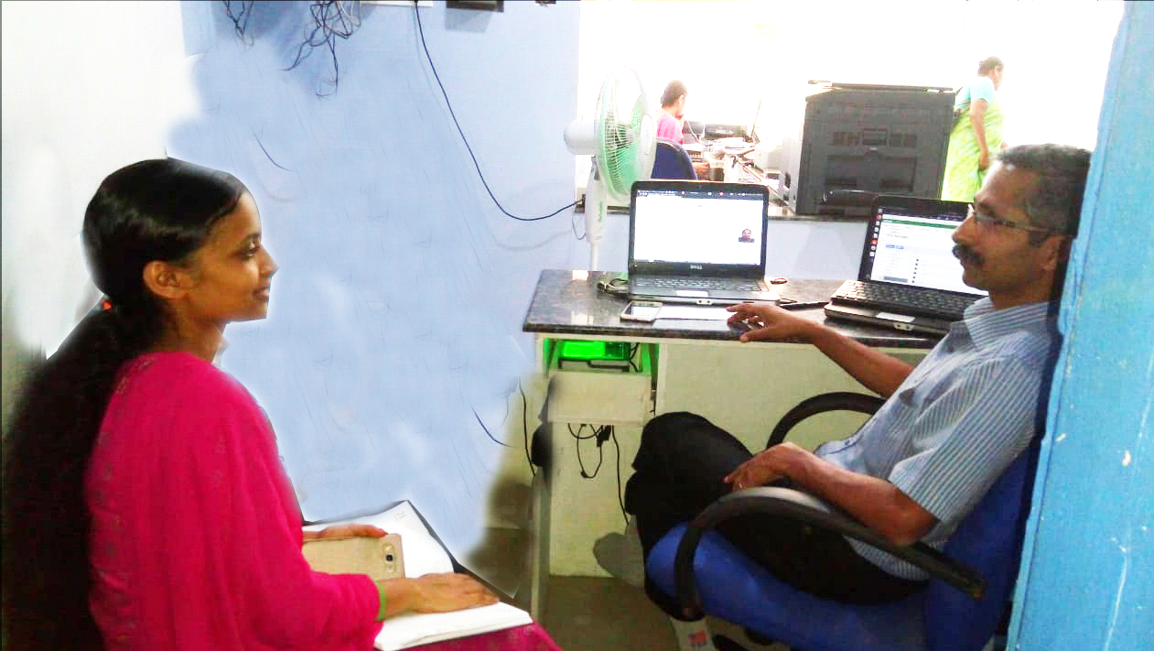

Fig: Interview with Mr. Shaji(VLE at Angadikadavu akshaya center)

**Interview with VLE:**

|  |  |  |  |  |
| --- | --- | --- | --- | --- |
| **No.** | **Questions** | | **Answers** | |
| 1 | | How many staffs are working in your akshaya center? | | Four staff including manager and receptionist | |
| 2 | | How you take or keep their information? | | I am write their personal information into their record book. | |
| 3 | | on that time you face any problem? | | Yes, I need lot of space to keep their details[record]. Also when I want one employee details that tme I required more time for searching. | |
| 4 | How you take the attendance of the staff? | | I take manually and I include weekly attendance then record that | |
| 5 | How to record the receiving amount of customer? | | now there is no separate record for each and every services, at the evening we calculate revenue. | |

**Interview with Staff:**

|  |  |  |
| --- | --- | --- |
| **No.** | **Questions** | **Answers** |
| 1 | How to handle the situation if more customers are present in akshaya for various services? | At present there is no proper arrangement for dealing customers. |
| 2 | How can you record customer details? | Now, we are not recording all customer details. |
| 3 | Did you give any bill to the customer | No |

**Interview with Customers:**

|  |  |  |
| --- | --- | --- |
| **No.** | **Questions** | **Answers** |
| 1 | Are you aware about the various services provided through the akshaya center? | From the study, it is clear that some people are aware about the various services provided through the akshaya center but majority of the people are not aware about the akshaya services |
| 2 | What are the main problems you are facing from akshaya center? | * In most of the times the customers are waiting large amount of time in akshaya center for getting service * Suppose I am going to akshaya center for particular services I don’t know what are the certificates needs to accomplish the services, it makes more difficulties to visit with corresponding certificates to the center |
| 3 | can you gave feedback on akshaya center? | no, we just tell them |

**2.4 Feasibility Study**

Feasibility study is made to see if the project on completion will serve the purpose of the organization for the amount of work, effort and the time that spent on it. Feasibility study lets the developer foresee the future of the project and the usefulness.

Feasibility study is a test of system proposed regarding its workability, impact on the organization, ability to meet the needs and effective use of resources. Thus when a new project is proposed, it normally goes through a feasibility study before it’s approved for development.

The document provide the feasibility of the project that is being designed and lists various areas that were considered very carefully during the feasibility study of this project such as technical, economical and behavioral feasibilities.

The proposed system is theoretically investigated to check the feasibility and found that they are more reliable and reliable in the cases given below. There are three aspects in the feasibility study portion of the preliminary investigation.

* Economic Feasibility
* Technical Feasibility
* Behavioral Feasibility
* Legal Feasibility

The proposed system must be evaluated from a technical point of view first, and if technical feasible their impact on the organization must be assessed. If compatible, the operational system can be devised. Then they must be tested for economic feasibility.

**Economic Feasibility**

The developing system must be justified by cost and benefit. Criteria to ensure that effort is concentrated on project, which will give best, return at the earliest. One of the factors which affect the development of a new system is the cost it would require. Since the system developed as part of project work, there is no manual cost to spend for the proposed system. Also all the resources are already available, it give an indication of the system is economically possible for development.

**Technical Feasibility**

The system must be evaluated from the technical point of view first. The assessment of this feasibility must be based on an outline design of the system requirement in the terms of input, output, programs, procedures and staff. Having identified an outline system, the investigation must go on suggest the type of equipment, required method developing the system, of running the system once it has been designed. The project should be developed such that the necessary functions and performance are achieved within the constraints. The project is developed within latest technology.

Through the technology may become obsolete after some period of time, due to the fact that newer version of some software supports older versions, the system may still be used. So there are only minimal constraints involved with this project. The system has been developed using PHP , the project is technically feasible for developed.

**Behavioral Feasibility**

People are inherently resistant to change and computers have been known to facilitate change. The AKSHAYA SAHAYI is designed in user friendly manner and we need not to provide any special training for the persons using this software. The operating system used is Windows 7, which is also user friendly. It does not have any operational barriers. So no need to provide any special training for using this application software and hence it is behaviorally feasible.

**Legal Feasibility**

Another aspect is legal feasibility. The system cannot create any violation of rules and regulation in the current AKHAYA CENTERES. That is, the system must follow all the rules and regulations that are applicable to the existing system. The AKSHAYA SAHAYI follows all these and will not make violation in the norms and rules of government. So the system is legally feasible.

**2.5. System Specifications**

**2.5.1. Software Specifications**

The software required for the application depends on the following factors.

* The flexibility of the software
* Software contracts
* Limitation of the software

**Software:**

Operating system : Windows XP/Vista/7/8/8.1

Front End : PHP

Back End : MYSQL

Web browser : Google Chrome

**2.5.2. Hardware Specifications**

The hardware required for the application depends on the following factors.

* Determining size and capacity requirements.
* Computer evaluation and measurement.
* Financial factors.
* Maintenance and support.

**Hardware:**

Processor : Pentium IV or Higher versions

RAM : 512 MB

HDD : 500GB or More

Monitor : Display Panel (1366*768)

Keyboard : Standard 104 keys

Mouse : Standard Mouse 3 Buttons

Printer : Laser/Inkjet

**2.6. Identification of Actors**

An actor is someone or something that interacts with the system. An actor is he /she what uses the system. An actor exchanges information with the system. Asking certain questions as detailed below can identify the actors of the system.

We can identify the actors through a list of questionnaires**.**

|  |  |  |
| --- | --- | --- |
| 1 | Who will use the main functionality of the system? | Admin, VLE,Staff and Customers |
| 2 | Who will lead support from the system and do their daily tasks? | VLE |
| 3 | Who will maintain and administrate the system? | Admin |
| 4 | Which hardware devices does the system need to handle? | Desktop computer, printer |
| 5 | With which other systems, does this system need to interact? | Database |
| 6 | Who was interested in the result produced by the system? | Admin, VLE,Staff and Customers |

The answers to these questions bring out the actors of the system:

* **Administrator**
* **VLE**
* **Staff**
* **Customers**

**2.7. Identification of Use Cases**

**2.7.1. Use Case Diagram**

In the analysis section, we identified the actors such as

* Administrator
* VLE
* Staff
* Customers

Here we need to specify the use cases of each actor.

**Identification of use cases**

A use cases represents the functionality of an actor. It is defined as a set of actions performed by a system, which yields an observable result. An ellipse containing its name inside the ellipse or below it represents it. It is placed inside the system boundary and connected to an actor with an association. This shows how the use cases and the actor interact.

To find out the use cases, ask the following questions to each of the actors.

* Which functions does the actor require from the system? What does the actor need to do?
* Does the actor need to read, create, destroy, modify or store some kind of information in the system?
* Does the actor has to be notified about events in the system, or does the actor needs to notify the system about something? What do those the events represent in terms of functionality?
* Could the actor’s daily work be simplified or made more efficient by adding new functions to the system (typically functions which are currently not automated in the system)

**Use cases for the actor administrator:**

|  |  |  |
| --- | --- | --- |
| **1** | Which functions does the Administrator require from the system? What does the Admin need to do? | Administrator is the association. Administrator can approve or reject VLE.Only approved VLE can use akshaya sahayi.admin can remove VLE.VLE can reply to the enquiries. |
| **2** | Does the Administrator need to read, create, destroy, modify or store some kind of information in the system? | Yes, the administrator may login to the system, approve/reject pending VLE registrations, Only association approved VLE can use this akshaya sahayi.also admin can remove VLE from akshaya sahayi. |
| **3** | Could the Administrator’s daily work be simplified or made more efficient by adding new functions to the system? | Yes, the system can reduce his/her daily work. |

It gives the following use cases for the actor Administrator:

* Approve VLE
* Reject VLE
* Remove Akshaya center
* Reply to enquiry
* Change password
* View VLE list

**Use cases for the actor VLE:**

|  |  |  |
| --- | --- | --- |
| **1** | Which functions does the VLE require from the system? | VLE need to perform the functionalities such as VLE can register their center in the akshaya sahayi,can register new employee, update their details, delete employee, staff attendance can record and view, can approve leave request from staff, send message to each staff, view feedback from customers and view customer details |
| **2** | Does the user need to read, create, destroy, modify or store some kind of information in the system? | Yes, the VLE may login to the system he can add new employee and mange their information and also he can manage leave and attendance of staff. |
| **3** | Could the user’s daily work be simplified or made more efficient by adding new functions to the system? | Yes, the system can reduce his/her daily work. |

It gives the following use cases for the actor VLE:

* Add new employee
* Update employee details
* Delete employee
* Mark attendance
* View attendance
* Approve/Reject leave
* View feedback
* Send Message
* View customer details
* Edit profile
* Change password

**Use cases for the actor staff:**

|  |  |  |
| --- | --- | --- |
| **1** | Which functions does the staff require from the system? | Staff main function is to manage the customers. It comprises the functions to add, give service to the customers. Staff can apply for leave, View message from VLE. |
| **2** | Does the user need to read, create, destroy, modify or store some kind of information in the system? | Yes, the hospital may login to the system in order to store doctor’s details, or to remove or modify the stored details of doctors in the system. |
| **3** | Could the user’s daily work be simplified or made more efficient by adding new functions to the system? | Yes, the system can reduce his/her daily work. |

It gives the following use cases for the actor Staff:

* Customer Registration
* Bill Print
* Apply Leave
* View leave status
* View message
* Give service

**Use cases for the actor customer:**

|  |  |  |
| --- | --- | --- |
| **1** | Which functions does the customer require from the system? | Customer have following functions. submit their queries, send mail directly to the association(admin).participate in live chat, directly send message to each VLE |
| **2** | Does the user need to read, create, destroy, modify or store some kind of information in the system? | Customer can submit their queries, send mail directly to the association(admin).participate in live chat,send message to each VLE |
| **3** | Could the user’s daily work be simplified or made more efficient by adding new functions to the system? | Yes, the system can reduce his/her daily work. |

It gives the following use cases for the actor Customer:

* Submit Queries
* Send mail
* Live Chat
* View Akshaya centers
* Send Message

**Use Case Diagram**

ADMIN

VLE

STAFF

CUSTOMER

**2.8 Activity Diagram**

The activity diagram supplements the use case by providing a graphical representation of the flow of interaction within a specific scenario. It uses rounded rectangles to imply a specific system function, arrows to represent flow through the system, decision diamonds to depict a branching decision, and solid horizontal lines to indicate that parallel activities are occurring.

The basic purposes of activity diagrams are similar to other diagrams. It captures the dynamic behavior of the system. Other diagrams are used to show the message flow from one object to another but activity diagram is used to show message flow from one activity to another.

So the purposes can be described as:

* Draw the activity flow of a system.
* Describe the sequence from one activity to another.
* Describe the parallel, branched and concurrent flow of the system.

Activity Diagram Admin

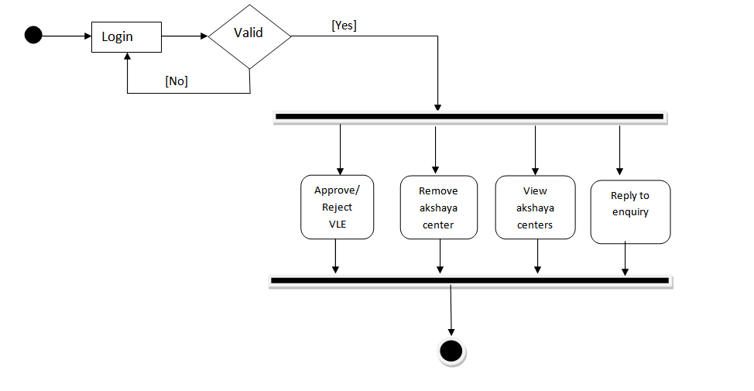

**Activity Diagram VLE**

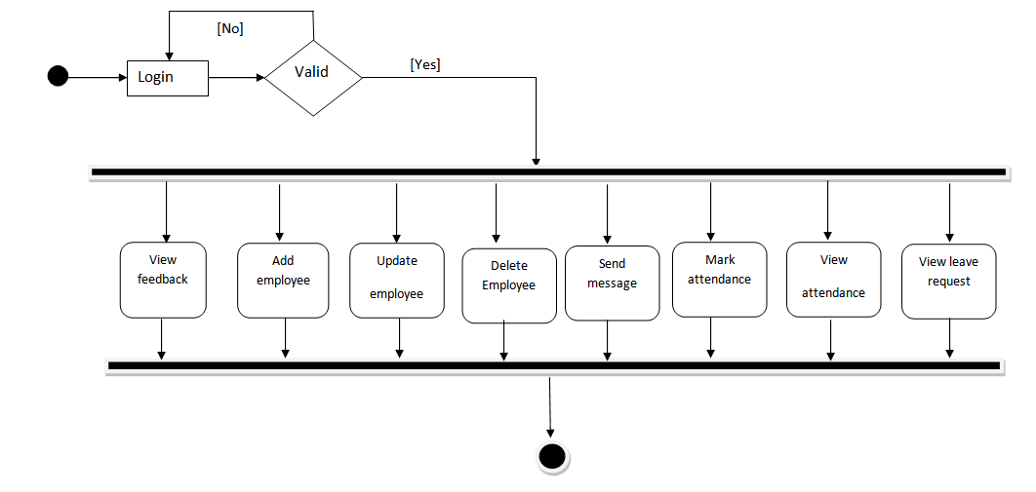

**Activity Diagram Staff**

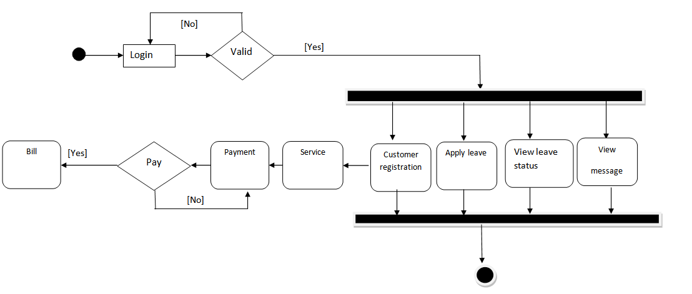

**Activity Diagram Customers**

Send Mail

Live Chat

View Akshaya centers

Send Message to VLE

Submit quires

**2.9 SEQUENCE DIAGRAM**

Sequence diagrams are an easy and intuitive way of describing the behavior of a system by viewing the interaction between the system and its environment. A sequence diagram shows an interaction arranged in a time sequence. It shows the objects participating in the interaction by their life lines and the messages they exchange, arranged in a time sequence.

A sequence diagram has two dimensions: a vertical dimension represents time, horizontal dimension represents different objects. The vertical line is called the object’s lifeline. The lifeline represents the object’s existence during the interaction. This form was first popularized by Jacobson. An object is shown as a box at top of a dashed vertical line. A role is slot for an object within a collaboration that describes the type of object that may play the role and its relationships to other roles. However, a sequence diagram does not show the relationships among the roles or the association among the objects. An object role is shown as a vertical dashed line, the life line.

Each message is represented by an arrow between the life lines of two objects. The order of these messages occur shown top to bottom on the page. Each message is labeled with the message name. The label also can include the argument and some control information and show self-delegation, a message that an object sends to itself, by sending the message arrow back to the same lifeline. The horizontal ordering of the lifelines is arbitrary. Often, all arrows are arranged to proceed in one direction across the page, but this is not always possible and the order conveys no information.

The sequence diagram is very simple and has immediate visual appeal- this is its greatest strength. A sequence diagram is an alternative way to understand the overall flow of the control of a program. Instead of looking at the code and trying to find out the overall sequence of behavior, we can use the sequence diagram to quickly understand that sequence.

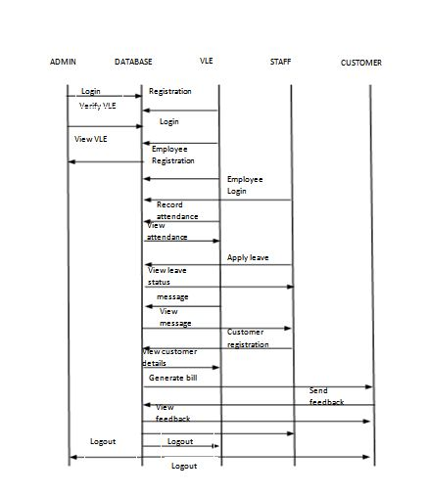

**3. SYSTEM DESIGN**

**System design**

Design is a meaningful engineering representation of something that is to be built. It is an iterative process through which requirements are translated in to a blueprint for constructing the software. The goal of the design phase is to plan a solution of the problem specified by the requirements document.

Major activities during the design phase are:

* Data Base Design
* Architectural Design
* Interface Design
* Modular Design

**3.1. DATABASE DESIGN**

A database is collections of inter related data stored with minimum redundancy to serve many users quickly and efficiently. In database design data independence, accuracy, privacy, and security are given higher priority. Database design is an integrated approach to file design. This activity deals with the design of the physical database. All entries and attributes have been identified while creating the database. The database design deals with the grouping of data into number of tables so as to reduce the duplication of data, minimize storage space, and retrieve the data efficiently.

Guidelines for designing a database:

* Design a relational schema so that it is easy to explain its meaning. Do not combine attributed from multiple entity and relationships type into single relation.
* Design the database schema so that no insertion, deletion or modification anomalies are present in the relation.
* As far as possible, avoid placing attributes in a base relation whose values may frequently be null.
* Design relation schemas so that they can be joined with equality conditions on attributes that are either primary keys or foreign keys in a way that no spurious tuples are generated.

**Advantage**

* Ease of use
* Data independence
* Accuracy and integrity
* Avoiding inordinate delays
* Recovery from failure
* Privacy and security.

**3.1.1 E-R DIAGRAM**

An entity-relationship diagram is a data modeling technique that creates a graphical representation of the entities, and relationship between entities, within an information system.

**There are three basic elements in ER models:**

* **Entities** are the “things” about which we seek information
* **Attributes** are the data we collect about entities.
* **Relationships** provided the structure needed to draw information from multiple entities.

**E-R Diagram Symbols:**

Entity

Attributes

Relation

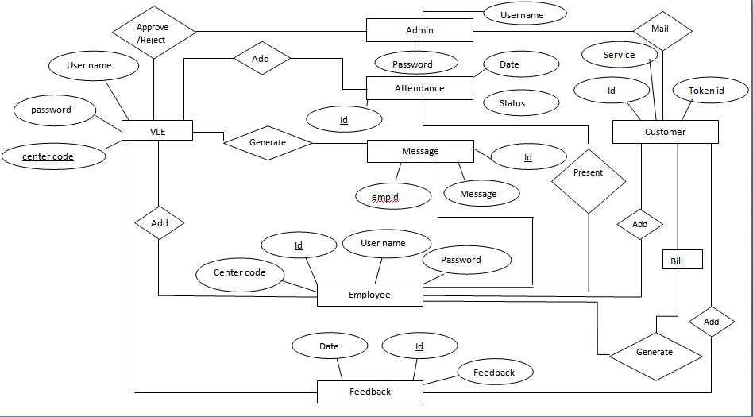

**3.1.2 TABLE DESIGN**

In the database all the information are stored in the form of tables. A table is simply a way storing data in rows and columns. In the system data is stored in many tables. The table structures are shown below with sample data.

**TABLES**

vle

|  |  |  |  |
| --- | --- | --- | --- |
| **Field** | **Data type** | **Key** | **Description** |
| Id | Int | Primary Key | Unique Identification of vle |
| Name | Varchar(20) |  | VLE name |
| centerlocation | Varchar(20) |  | Location |
| Landmark | Varchar(20) |  | Landmark |
| panchayath | Varchar(20) |  | Panchayath |
| Block | Varchar(20) |  | Block |
| District | Varchar(20) |  | District |
| Email | Varchar(20) |  | Email |
| Phone | Varchar(20) |  | Phone |
| Mobile | Varchar(20) |  | Mobile |
| Password | Varchar(20) |  | Password |
| Photo | Varchar(20) |  | Photo of VLE |
| Status | Varchar(20) |  | Approved/Reject |

enquiry_tb

|  |  |  |  |
| --- | --- | --- | --- |
| Field | Data type | key | Description |
| Id | Int | Primary Key | Unique identification |
| Name | Varchar(20) |  | Name of user |
| Email | Varchar(20) |  | Email of user |
| Subject | Varchar(20) |  | subject |
| Question | Varchar(20) |  | Question |
| Reply | Varchar(20) |  | Reply |
| Date | Date |  | Date |

association

|  |  |  |  |
| --- | --- | --- | --- |
| Field | Data type | key | Description |
| Username | Varchar(20) | Primary Key | Username |
| Password | Varchar(20) |  | Password |

staff_reg

|  |  |  |  |
| --- | --- | --- | --- |
| **Field Name** | **Data Type** | **Key** | **Description** |
| Id | Int | Primary | Unique identifier for staff |
| centercode | Varchar(20) | Foreign Key | Primary key of vle table |
| firstname | Varchar(50) |  | First name |
| lastname | Varchar(20) |  | Last name |
| Phone | Long int |  | Phone |
| Place | Varchar(60) |  | Place |
| Email | Email |  | Email |
| Gender | Varchar(30) |  | Gender |
| designation | Varchar(20) |  | Designation |
| Grade | Varchar(20) |  | Grade |
| Salary | Int |  | Salary |
| marital_status | Varchar(20) |  | Marital status |
| blood_group | Varchar(20) |  | Blood group |
| qulification | Varchar(20) |  | Qualification |
| experience | Varchar(20) |  | Experience |
| password | Varchar(20) |  | Password |
| Photo | Varchar(500) |  | Photo |
| d&t | Date |  | Date of joining |

attendence

|  |  |  |  |
| --- | --- | --- | --- |
| Field | Data type | key | Description |
| Id | Int | Primary Key | Unique identification of attendence |
| Date | Date |  | Date |
| Centercode | Varchar(20) | Foreign Key | Primary key of vle table |
| Empid | Int | Foreign Key | Primary key of staff_reg |
| Status | Varchar(20) |  | Status |

customer_reg

|  |  |  |  |
| --- | --- | --- | --- |
| Field | Data type | key | Description |
| Id | Int | Primary key | Unique identification of customer |
| Date | Date |  | Date |
| Centercode | Varchar(20) | Foreign key | Primary key of vle table |
| Tockenid | Varchar(20) |  | Token id |
| Name | Longint |  | Name |
| Mobile | Varchar(20) |  | Mobile |
| Place | Varchar(20) |  | Place |
| Email | Varchar(20) |  | Email |
| housename | Varchar(20) |  | House name |
| Gender | Varchar(20) |  | Gender |
| Item | Varchar(20) |  | Item |
| Cash | Varchar(30) |  | Cash for the service |

message

|  |  |  |  |
| --- | --- | --- | --- |
| Field | Data type | Key | Description |
| Id | Int | Primary key | Unique identification |
| Empid | Int | Foreign key | Primary key of staff_reg |
| Message | Varchar(20) |  | Message |
| Date | Date |  | Date |

feedback

|  |  |  |  |
| --- | --- | --- | --- |
| Field | Data type | Key | Description |
| Id | Int | Primary key | Unique identification |
| vleid | Int | Foreign key | Primary key of vle table |
| name | Varchar(20) |  | Name |
| feedback | Varchar(20) |  | Feed back |
| d&t | Date |  | Date |

tblleaves

|  |  |  |  |
| --- | --- | --- | --- |
| Field | Data type | Key | Description |
| Tid | Int | Primary key | Unique identification |
| LeaveType | Varchar(20) |  | Leave type |
| FromDate | Date |  | Leave starting date |
| ToDate | Date |  | Leave ending date |
| Description | Varchar(220) |  | Reason for leave |
| Postingdate | Date |  | Leave apply date |
| status | Varchar(20) |  | Approve/Reject |
| empid | Int | Foreign key | Primary key of staff_reg |
| centercode | Varchar(20) | Foreign key | Primary key of VLE |

**3.2.Architectural Design**

**3.2.1.Data Flow Diagram**

A data flow diagram is a graphical technique that depicts data flow and transforms that are applied as data move from input to output. The DFD is used to represent increasing information flow and functional details. A Level 0 DFD also called a fundamental system model or context model represents the entire software elements as a single bubble with input and output indicated by incoming and outgoing arrows respectively. Additional process and information flow parts are represented in next level i.e., Level 1 DFD. Each of the processes represented at level 1 are sub functions of overall system depicted in the context model.

**Data flow diagram symbols:**

Source/Destination of Data

Data flow

Process

Storage

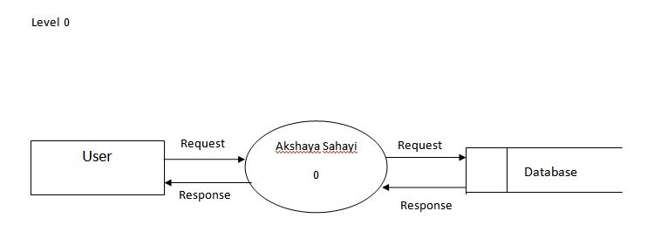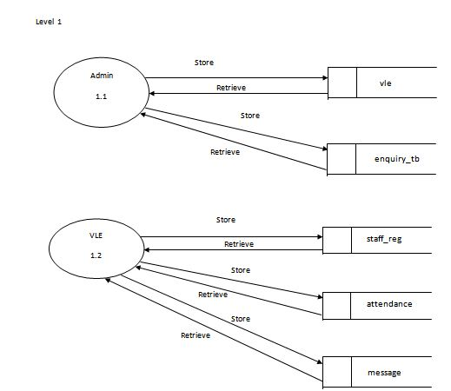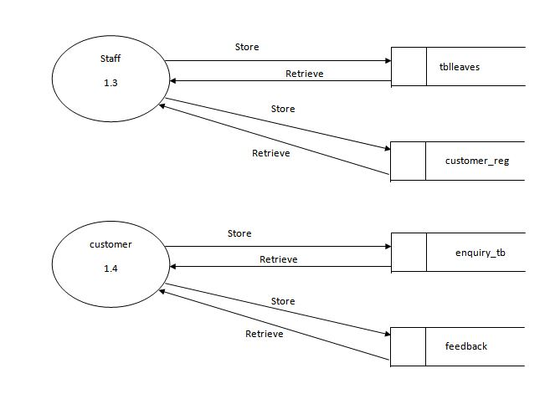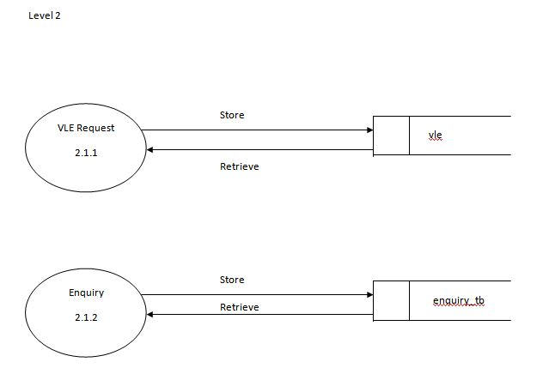

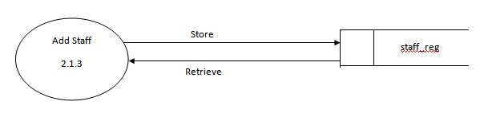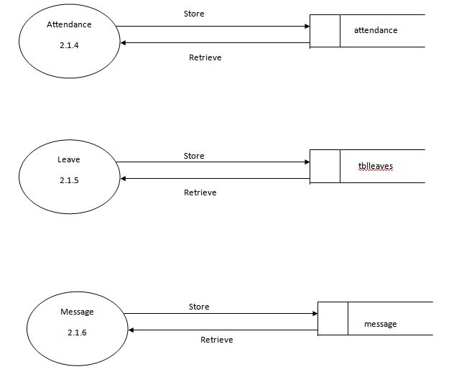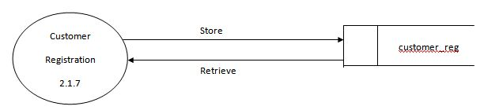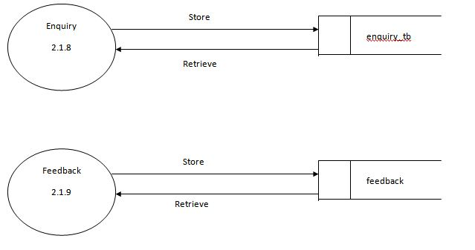

**3.3 Interface Design**

An interface design elements for the software tell how information flows into and out of the system and how it is communicated among the components as part of the architecture.

**Input Design**

Input design is the link between the information system and users and those steps that are necessary to put transaction data into a usable form for processing data entry. Instructing the computer to read data from a written printed document can active the activity of putting data into the computer for processing or it can occur by keying data directly into the system. The design of input focusing on controlling the errors, avoid delay, and keeping the process simple.

System analyst decides the following input design details.

* What data to input?
* What medium to use?
* How the data is arranged and coded?

In my project named akshaya sahayi, I tried to include the following design constrains provided in the software engineering.

***1: Avoid Scattering of fields in the page***

In all pages of the software the textboxes (which provided to input some data), label (which label the textboxes), combo box (list a set of values) etc. all are arranged in a neat and well format. It provides a simple look to the pages. The buttons are placed at the bottom of the page and can easily accessible to the user. The menus are arranged below the heading and at a minimum level of menus are arranged with pages. Menu provides the continuity to the pages.

***2: User only needs to enter a minimum amount of data***

All pages contain a minimum amount data, but most essentials. No page provides or wanted bulky of data. It also provides more easiness to the user. It creates more flexible the software to the end user. Also the operation continues by single click.

***3: Avoid confusions in the page***

All pages have a well-defined menus and each menu name indicate its purpose. So the user can easily load and unload between the pages. Each subpage has a sign out menu and using that the user can reach at the home page. Totally the well-defined page link avoid the problems occurred at page loading.

**Output Interfaces**

Designing computer should proceed in well thought out manner. The term output means any information produced by the information system whether printed or displayed. Output design is a process that involves designing necessary outputs that have to be used by varies users according to requirement. The efficient intelligent output design should remove the system relationship with the users and help in decision making.

When designing the output, system analyst must accomplish the following:

* Determine the information present
* Decide whether to print, display the information and select output medium
* Arrange information in acceptable format.

In my project, the outputs are in a well format and it provides the output in a correct and neat format.

**3.4 Procedural Design**

The system has four modules they are,

* Administrator module
* VLE module
* Staff module
* Customer

**1. Administrator module**

Administrator is the one who controls the organization. He can approve or reject VLE, remove akshaya centers, and reply to enquiry.

Following are the functions that can be performed by the administrator.

* Approve VLE
* Reject VLE
* Remove Akshaya center
* Reply to enquiry

*Approve VLE:*

Administrator can approve *VLE* .

*REJET VLE:*

Administrator can reject *VLE request*.

*Remove akshaya center:*

Administrator can remove akshaya center.

*Reply to enquiry:*

Administrator can reply to enquiry.

**2. *VLE* module**

VLE perform different functionalities such as add new employee, update employee details, delete employee details, mark attendance, view attendance, approve or reject leave, view feedback and view customer details.

Following are the functionalities that can be performed by the VLE.

* Add employee
* Update employee details
* Delete employee
* Mark attendance
* View attendance
* Approve/Reject leave
* View feedback
* View customer details
* Send message
* Edit profile
* Change password

*Add employee:*

VLE can add new employee and VLE can give username and password to the employee.

*Update employee details:*

VLE can update employee details.

*Delete employee details:*

VLE can delete employee details.

*Mark attendance:*

VLE can mark and view the attendance details

*Approve or Reject leave:*

VLE can approve or reject leave request from employee

*Send Message:*

VLE can send message to the staff.

*View Feedback:*

VLE can view feedback from customers

*View Customer Details:*

VLE can view customer details

**3. Staff module**

Staff function mainly contain the management of customers. Customer registration, bill print, apply leave and give service to the customers.

Following are the functionalities that can be performed by the staff.

* Customer Registration
* Bill Print
* Apply Leave
* Give service

*Customer Registration:*

Staff can register new customer and give token to customers. Then based on these token the staff can easily manage customers.

*Bill Print:*

Staff can give bill to the customers based on their service given to the customers.

*Apply Leave:*

Staff can send leave request to the VLE.

*Give Service:*

Staff can give service to the customers based on the token number.

**4. Customer module**

Customer requires the functionalities such as submit queries, send mail to the admin, participate in live chat ,view akshaya centers in kerala.Send message to the VLE.

Following are the functionalities that can be performed by the customer.

* Submit Queries
* Send mail
* Live Chat
* View Akshaya centers
* Send Message

*Submit queries:*

Customers can submit queries VLE can reply to that.

*Send mail:*

Customers can directly send mail to the VLE.

*Live chat:*

Customers can participate in live chat and they can ask questions related akshaya services and also related doubts.

*View Akshaya centers:*

Customers can view the akshaya centers that are register in the akshaya sahayi.

*Send message:*

Customers can directly send message to the VLE.

**4. Coding**

**4.1.Description of Software Used**

**Php**

PHP is a general purpose scripting language that is especially suited for web development. PHP generally runs on a web server, taking PHP code as its input and creating web pages as output. It can also be used for command line scripting and client side GUI applications. PHP primarily acts as a filter, taking input from a file or stream containing text and/or PHP instructions and outputs another stream of data; most commonly the output will be HTML.

As with many scripting languages, PHP scripts are normally kept as human readable source code. In this case PHP scripts will be compiled at runtime by the PHP engine, which increases the execution time.

**MYSQL**

MySQL is a multithreaded, multi-user SQL database management system. The basic program runs as a server providing multi-user access to number of databases. The data in MySQL is stored in database object called tables. A table is collection of related data entries and it consists of columns and rows. Databases are useful when storing information categorically.In database each table is identified by a name. Tables contain records with data. A query is a question or a request. With MySQL, we can query a database for specific information and have a record set returned.

**4.2 CODING PRINCIPLE**

The input to the coding phase is the design document. During coding phase, modules identified in the design document are coded according to the module specification. Objectives of coding phase are, to transform design into code and unit test the code.

**4.2.1 Coding Guidelines**

* Code should be easy to understand.
* Don’t take pride in cryptic code.
* Code should be well documented.
* Comments should be present.
* Functions should be small.
* Do not use Go-to statement.
* Do not use the same variable for multiple purposes.
  1. **SAMPLE CODE**

**Login:**

<?php

session_start();

?>

<!DOCTYPE html>

<!--[if lt IE 7]><html class="lt-ie9 lt-ie8 lt-ie7"><![endif]-->

<!--[if IE 7]><html class="lt-ie9 lt-ie8"><![endif]-->

<!--[if IE 8]><html class="lt-ie9"><![endif]-->

<!--[if gt IE 8]><!--><html><!--<![endif]-->

<head>

<title>akshaya</title>

<link rel="icon" href="Tourism Template/images/site_icon.png">

<meta charset="utf-8">

<link rel="stylesheet" href="Tourism Template/css/foundation.min.css">

<link rel="stylesheet" href="Tourism Template/css/superfish.css">

<link rel="stylesheet" href="Tourism Template/css/stylesheet.css">

<link rel="stylesheet" type="text/css" href="Sweet Alerts/sweetalert.css">

<script src="Sweet Alerts/sweetalert.min.js"></script>

<script src="Tourism Template/js/vendor/custom.modernizr.js"></script>

<script>

Modernizr.load({

// test if browser understands media queries

test: Modernizr.mq('only all'),

// if not load ie8-grid

nope: 'css/ie8-grid-foundation-4.css'

});

</script>

<!--[if lt IE 9]>

<link rel="stylesheet" href="Tourism Template/css/ie-fixes.css">

<![endif]-->

<style>

.head_a

{

font-family:Verdana;

}

body {

background-image: url(Slider%20Images/admin-login.jpg);

}

</style>

<meta http-equiv="Content-Type" content="text/html; charset=utf-8"></head>

<body>

<div class="header">

<div class="row">

<div class="columns large-12">

<div class="row header-inner">

<?php

include"menu_header.php";

?>

</div>

</div>

</div>

<div class="row">

<div class="columns large-12 small-top-menu">

<div class="row">

<div class="columns large-12 plr0 top-nav">

<form name="dropdown" class="dropdown" action="#">

<nav>

<section>

<select name="selected" id="target" accesskey="E" onChange="goToNewPage(document.dropdown.selected)">

<option value="index.html">home</option>

<option value="about.html">about us</option>

<option value="blog.html">blog</option>

<option value="gallery.html">gallery</option>

<option value="services.html">services</option>

<option value="contact.html">contact us</option>

</select>

</section>

</nav>

</form>

</div>

</div>

</div>

</div>

</div>

<div class="row content-wrapper">

<div class="columns large-12">

<div class="row wrapper">

<div class="columns large-12 content ">

<h1 class="page-title">Sign In - Admin</h1>

<div>

<h2 class="sub-title" style="font-family:Verdana">Gateway of opportunities.......</h2>

</div>

<div class="row contact-form">

<div class="columns large-8" style="font-family:Verdana">

<form id="contact-form" method="post" action="">

<table style="width:500px;">

<tr>

<td>

<input type="text" name="txtuname" placeholder="Username:">

</td>

</tr>

<tr>

<td>

<input type="password" name="txtpswd" placeholder="Password:">

</td>

</tr>

<tr>

<td>

<input type="submit" class="button" name="btn" value="sign in">

</td>

</tr>

</table>

</form>

</div>

<div class="columns large-4">

<div id="map_canvas"></div>

</div>

</div>

</div>

<div class="row collapse">

<div class="columns large-12"> </div>

</div>

</div>

</div>

</div>

<div class="credit-row">

<div class="row">

<div class="columns large-11 credit"> &copy; 2045 All rights reserved by <a href="#">Calisto.</a> Design by: <a href="http://topwebsitetemplates.org">topwebsitetemplates.org</a></div>

<div class="columns large-1"> <img src="Tourism Template/images/toparrow.png" alt="" class="scrollToTop"> </div>

</div>

</div>

<script src="Tourism Template/js/jquery.min.js"></script>

<script src="Tourism Template/js/hoverIntent.js"></script>

<script src="Tourism Template/js/superfish.js"></script>

<script src="Tourism Template/Tourism Template/js/google-maps.js"></script>

<script>

Modernizr.load({

test: Modernizr.placeholder,

nope: 'js/placeholder.min.js'

});

function goToNewPage() {

if (document.getElementById('target').value) {

window.location.href = document.getElementById('target').value;

}

}

</script>

<script>

$(document).ready(function () {

$('ul.sf-menu').superfish({

animation: {

height: 'show'

},

delay: 400

});

$("img.scrollToTop").click(function () {

$("html, body").animate({

scrollTop: 0

}, "slow");

});

});

</script>

</body>

</html>

<?php

if(isset($_POST['btn']))

{

include("connection.php");

$q=mysql_query("select * from association where username='".$_POST['txtuname']."' and password='".$_POST['txtpswd']."'");

if($a=mysql_fetch_array($q))

{

$_SESSION['id']=$a[0];

$_SESSION['username']=$a['username'];

?>

<script type="text/javascript">window.location.href="Admin/home.php";</script>

<?php

}

else

{

?>

<script type="text/javascript">

sweetAlert({

title: "Error!",

text: "Invalid Username or Password!",

type: "error",

confirmButtonText: "Ok"

});

</script>

<?php

}

}

?>

**5 TESTING**

**5.1 TESTING STRATEGIES**

For software that is newly developed, primary importance is given to testing the system. It is the last opportunity for the developer to detect the possible errors in the software before handing over it to the customer. Testing is the processes by which the developer will generate a set of data, which gives the maximum probability of finding all types of errors that can occur in the software.

The various steps in testing the system can be listed as below:

1. Running the program to identify any errors that might have occurred while feeding the program into the system.
2. Applying the screen formats to regulate users to extend, so that the screens are comprehensible to the user.
3. Presenting the formats to the administration for the purpose of obtaining approval and checking if any modification has to be done. Obtaining feedbacks from users and analyzing the scope for improvement.
4. Checking the data accessibility from the data server and whether any improvement is needed or not.

# The following are the types of Testing:

# Unit Testing

# Integration Testing

* System Testing
* Acceptance Testing
* Validation Testing

**5.1.1 Unit testing**

Unit testing is done on individual modules as they are completed and become executable. It is carried out to screen wise, each screen being identified as an object. Attention is diverted to individual modules, independently to one another to locate in coding and logic.

In unit testing,

* Module interface is tested to ensure that information properly flows into and out of the program under test.
* Local data structures are examined to ensure that data stored temporarily maintains its integrity during all steps in algorithm execution.
* Boundary condition is tested to ensure that the module operates properly at boundaries established to limit or restrict processing.
* All independent paths through the control structures are executed to ensure that all statements in the module have been executed at least once.
* Error handling paths are also tested.

Each module can be tested using the following two strategies:

|  |  |  |  |  |
| --- | --- | --- | --- | --- |
| **No:** | **Test Scenario** | **Expected Result** | **Observed Result** | **Result** |
| **1** | Enter wrong user name and pass word. | Display login form again with a warning message. | Message displayed. | Pass |
| **2** | Enter correct user name and wrong password. | Display login form again with a warning message. | Message displayed. | Pass |
| **3** | Enter correct user name and password. | Users can login into the system. | Appropriate home page is displayed. | Pass |
| **4** | Press login button without filling the user name and password. | Display a warning message to fill the fields. | Warning message is displayed. | Pass |

**TEST CASES**

**Registration form**

|  |  |  |  |  |
| --- | --- | --- | --- | --- |
| No: | **Test Scenario** | **Expected Result** | **Observed Result** | **Result** |
| 1 | Form displayed. | Display the registration form. | Form loaded | Pass |
| 2 | Enter the name in integers. | Display an invalid message. | Invalid message displayed | Pass |
| 3 | Enter the mobile number in characters. | Display an invalid message. | Invalid message displayed. | Pass |
| 4 | Enter the mobile number more than and less than 10 integers. | Display an invalid message. | Invalid message displayed. | Pass |
| 5 | Click the save button without filling the details | Display a warning message to fill the details. | Warning message displayed. | Pass |
| 6 | Click on save button with filled fields. | Accept the details. | Registration successfully done. | Pass |
| 7 | Click cancel button | Clear all fields to blank | All fields cleared. | Pass |

**View VLE**

|  |  |  |  |  |
| --- | --- | --- | --- | --- |
| No: | **Test Scenario** | **Expected Result** | **Observed Result** | **Result** |
| 1 | Form displayed. | Display form with all controls. | Form loaded with all controls. | Pass |
| 2 | Click on the button. | View form displayed with valuable details | Result displayed correctly. | Pass. |

**Black Box Testing**:

In this strategy some test cases are generated as input conditions that fully execute all functional requirements for the program. This testing has been uses to find errors in the following categories.

* Incorrect or missing function
* Interface errors
* Errors in data structure or external database access
* Performance errors
* Initialization and termination errors

In this testing only the output is checked for correctness. The logical flow of data is not checked.

**White Box Testing:**

In this the test cases are generated on the logic of each module by drawing flow graphs of that module and logical decisions are tested on all the cases. It has been uses to generate the test cases in the following cases:

* Guarantee that all independent paths have been executed.
* Execute all logical decisions on their true and false slides.
* Execute all loops at their boundaries and within their operational bounds.
* Execute internal data structure to ensure their validity.

**5.1.2 Integration testing**

Integration testing is a symmetric technique for constructing the program structure while at the same time conducting tests to uncover errors associated with interfacing. Unit tested module were taken and a single program structure was built that has been dictated by and tested in small segments, where errors were easy to locate and rectify. Each database or table manipulation operation was written as single program was tested again with numerous test data to check for its functionality. Integration testing ensures that software and subsystems work together a whole. It tests the interface of all the modules to make sure that the modules behave properly when integrated together.

|  |  |  |  |  |
| --- | --- | --- | --- | --- |
| **No** | **Input/procedure** | **Expected Result** | **Actual Result** | **Pass/Fail** |
| 1. | Check the value pass between different forms are appropriate format | Appropriate operations of different forms. | Same as expected. | Pass |

**5.1.3 System testing**

System testing is used test the entire system (Integration of the all modules). It also tests to find the discrepancies between the system and the original objective, current specification and system documentation. The entire system is checked to correct deviation to achieve correctness. System testing involves in-house testing of the entire system before delivery to the user. Its aim is to satisfy the user the system meets all requirements of the client’s specifications.

|  |  |  |  |  |
| --- | --- | --- | --- | --- |
| **No** | **Input/procedure** | **Expected Result** | **Actual Result** | **Pass/Fail** |
| 1. | Check whether indented output is obtained. | All operations are carried out properly. | Same as expected. | Pass |

**5.1.4 Acceptance testing**

It is a pre-delivery testing in which entire system is tested at client’s site on real world data to find errors.

**5.1.5. Validation testing**

At the conclusion of integration testing, software is completely assembled as a package, interfacing errors have been uncovered and corrected and a final series of software tests begins validation test has been conducted one of the two possible conditions exists. One is the function or performance characteristics confirm to specification and are accepted and the other is deviation from specification is uncovered and a deficiency list is created.

**6 IMPLEMENTATION**

**6.1 IMPLEMENTATION**

Implementation is the process of deploying the new system in the operational environment. Proper implementation is essential to provide a reliable system to meet the organizational requirement. There are four types of implementation methods. They are Direct Changeover, Phased Implementation, Parallel Run and Pilot Approach. The most commonly used implementation methods are Pilot Approach and Parallel Run.

**System Implementation**

System implementation is the stage where the theoretical design is turned into a working system. The system can be implemented only after through testing is done and if it if found to work according to specifications. The following methods were undergone.

Testing developed programs with updating.

* Correction of errors identified.
* Creating the tables of the system with actual data.
* Making necessary changes with actual data.
* Doing a parallel run of the system to find out any errors identified and to correct them.
* Training of user personnel’s.

A crucial phase in the system life cycle is the successful implementation of the new system design. Implementation simply means converting a new system design into operation. This involves creating computer compatible files, training, and telecommunication network before the system is up and running. A crucial factor in conversion is not disrupting the functioning of organization. Actual data were input into the program and the working of the system was closely monitored. It is a process of converting a new or revised system into an operational one. It is the essential stage in achieving a successful new system because usually it involves a lot of upheaval in the user. It must therefore be carefully planned and controlled to avoid problems.

The implementation phase involves the following tasks:

1. Careful planning.

2. Investigation

3. Design of methods

4. Training of the staff in the changeover phase.

5. Evaluation of changeover.

The implementation method used to implement “Akshaya Sahayi” is parallel run. That is, the new system will work parallel to the existing system. The new system will replace the existing system completely.

is developed as a online application. The language selected to program this software is php. The reason for selecting this language is a simple and powerful language.

Technologies used in the development of the software are:

* Language : php
* Database : mysql
* Web Server : Google Chrome
* Operating System : Windows

**7.CONCLUSION**

**7.1 CONCLUSION**

Akshaya Sahayi is a online application and it has been developed, tested, documented and implemented successfully. The main objective of the system was brought into effect. The system is developed in php as front-end tool and MySQL as backend tool.

This system however can be used by wide range of common peoples in the society, employees, VLE and akshaya association. It helps the customer to know the what type of services are given from the different akshaya centers and also avoid queue for getting service. Akshaya sahayi that help common peoples to get government services easily.

The important benefits that have been found out through the implemented system are:

1. User friendly.
2. Simplified operation.
3. Reduced processing time.
4. Accurate result providing.
5. More reliability.
6. Increases accuracy.

**8.REFERENCES**

8.1 WEBSITES

[www.w3school.com](http://www.w3school.com)

<https://www.codeproject.com>

<https://www.tutorialspoint.com>

[www.youtube.com](http://www.youtube.com)

**9.APPENDIX**

Home page

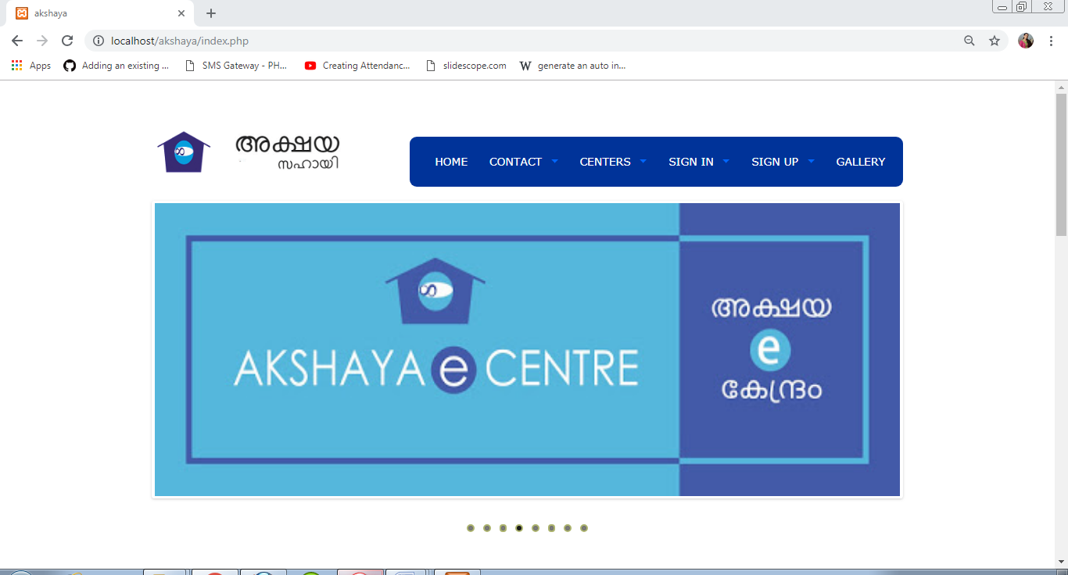

Contact page

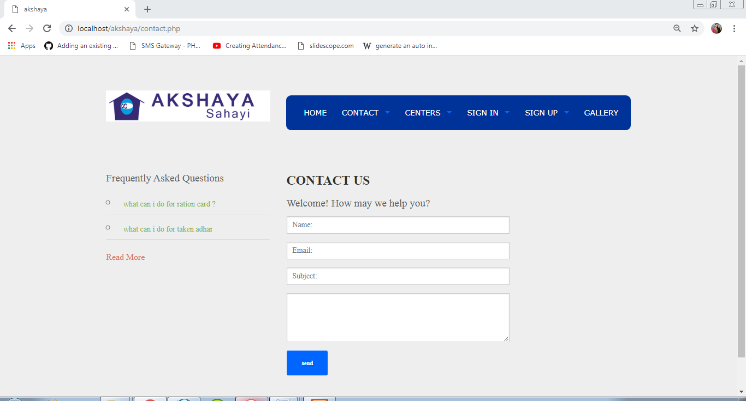

Mail

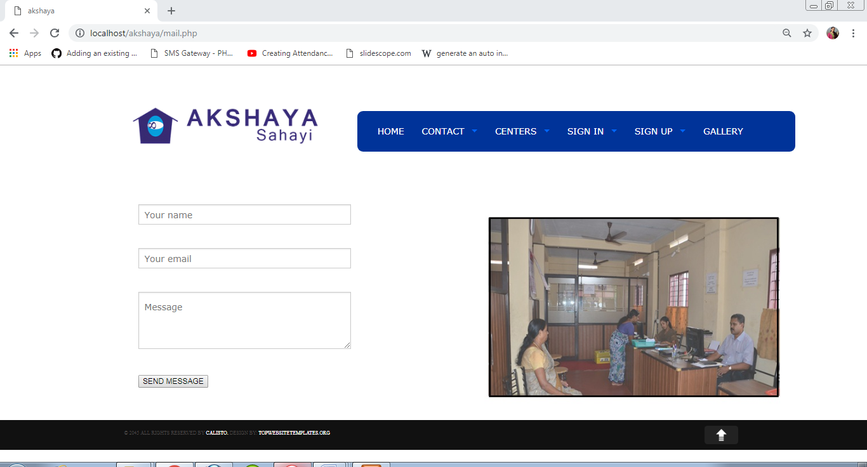

Live Chat

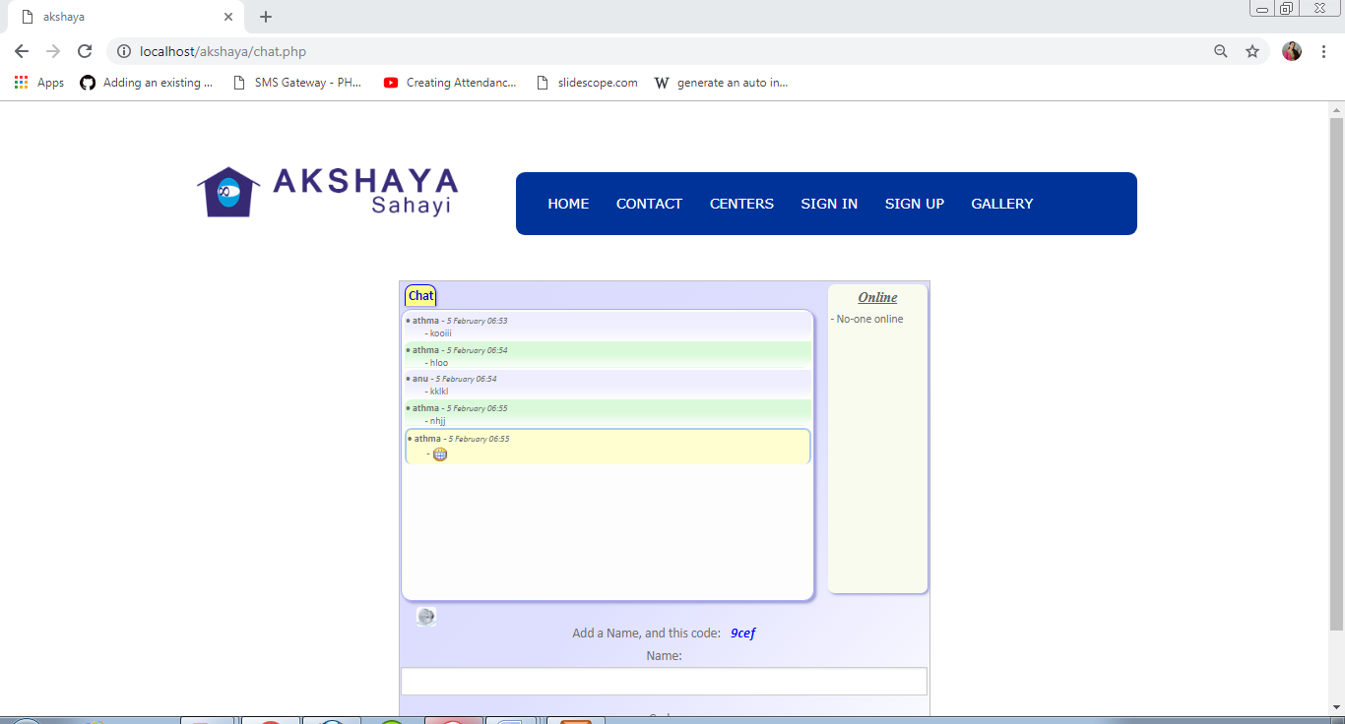

VLE List

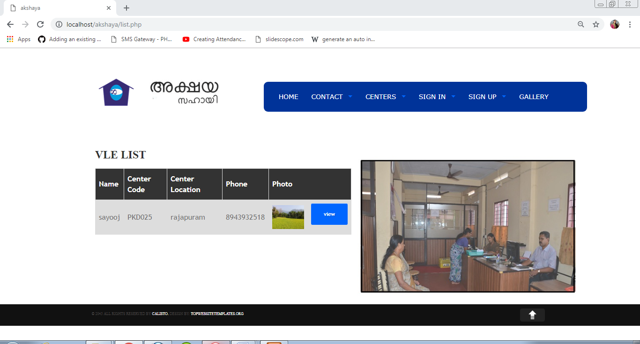

VLE Details

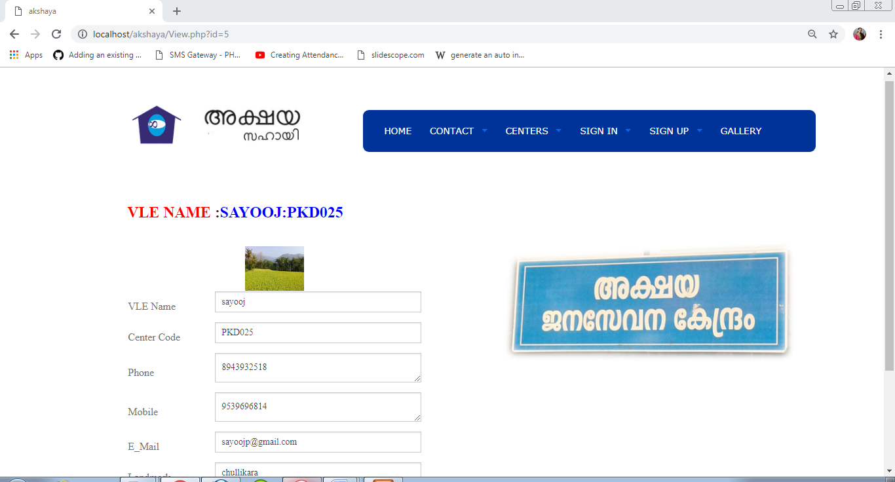

Admin Login

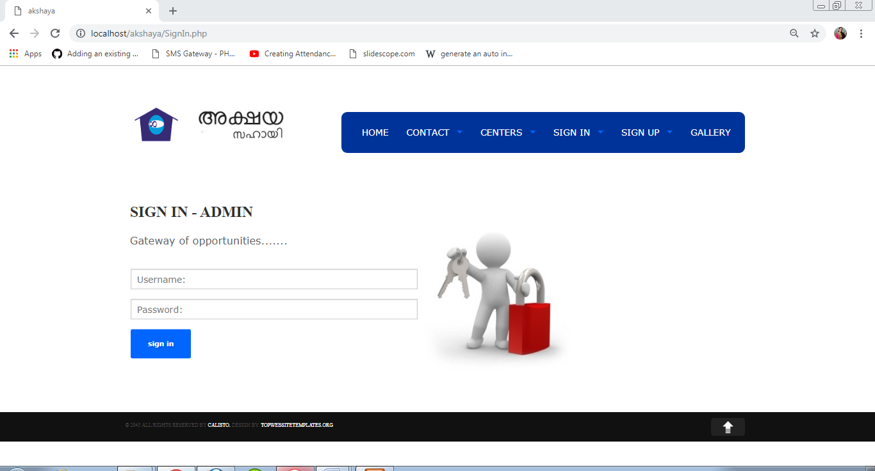

Login VLE

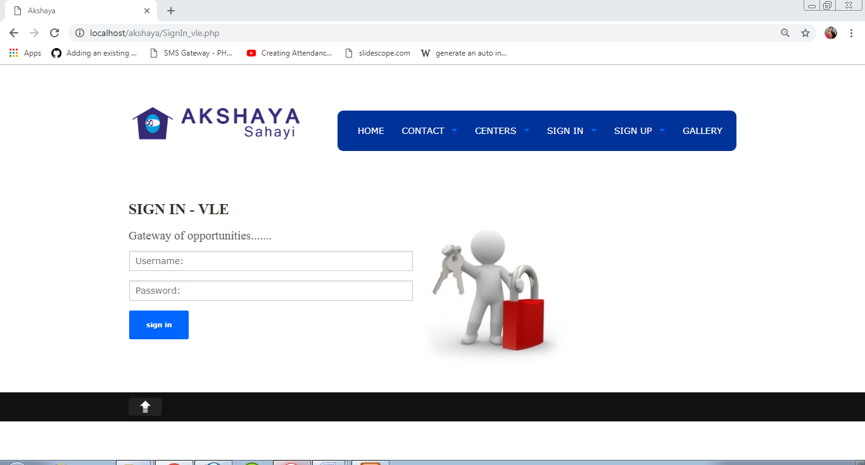

Login staff

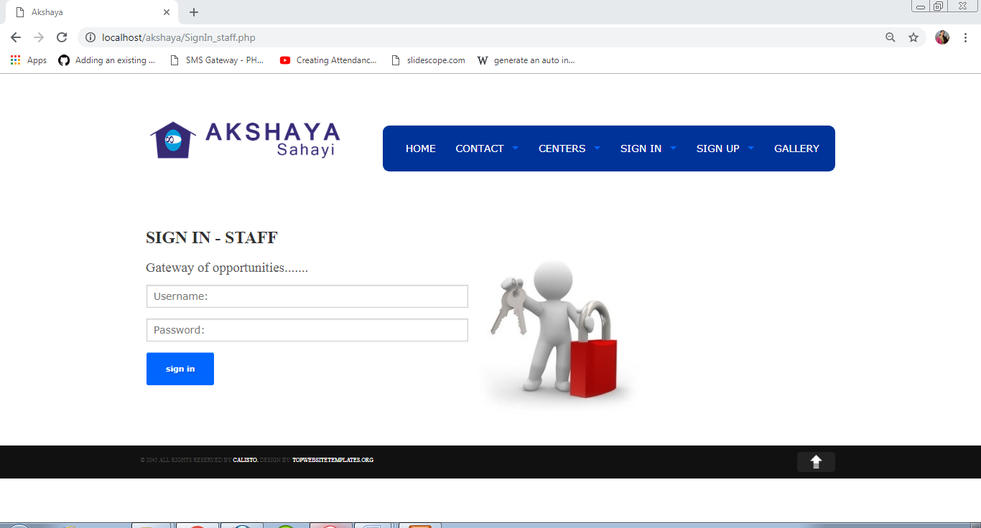

Sign up VLE

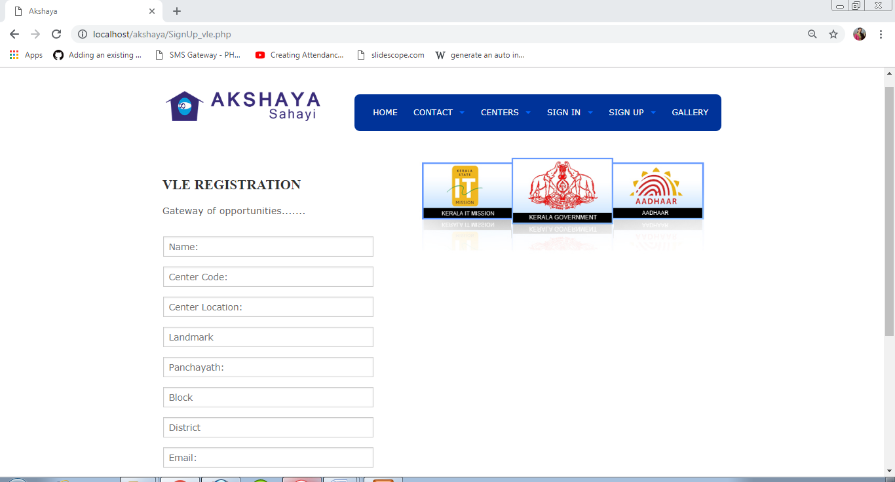

VLE list

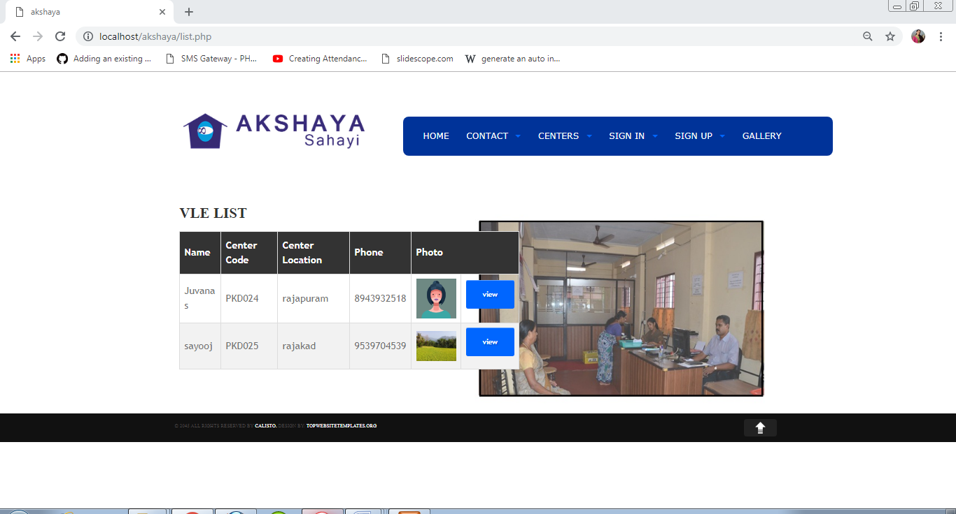

Send Message

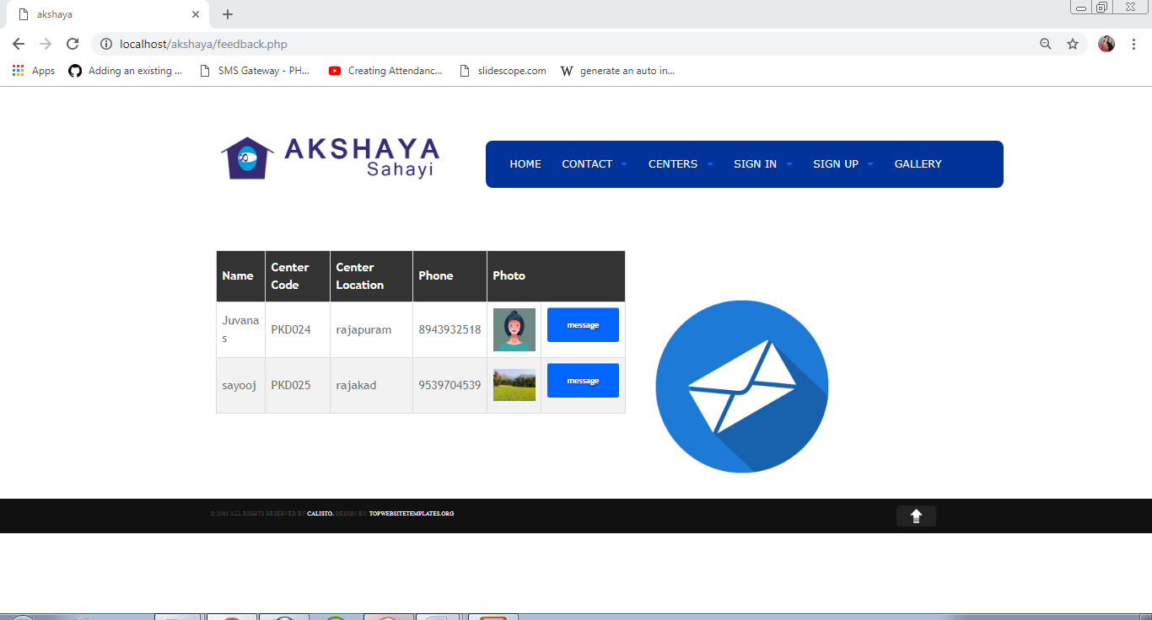

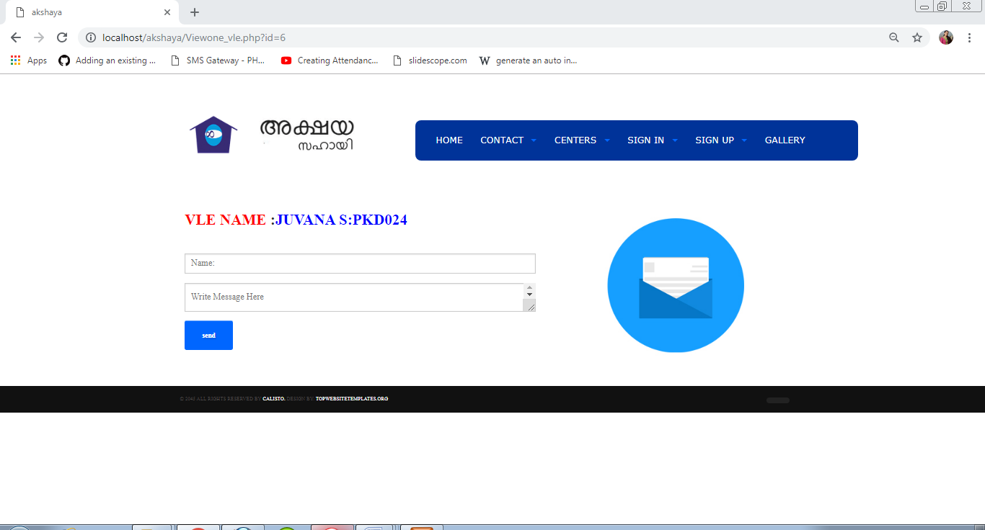

Services

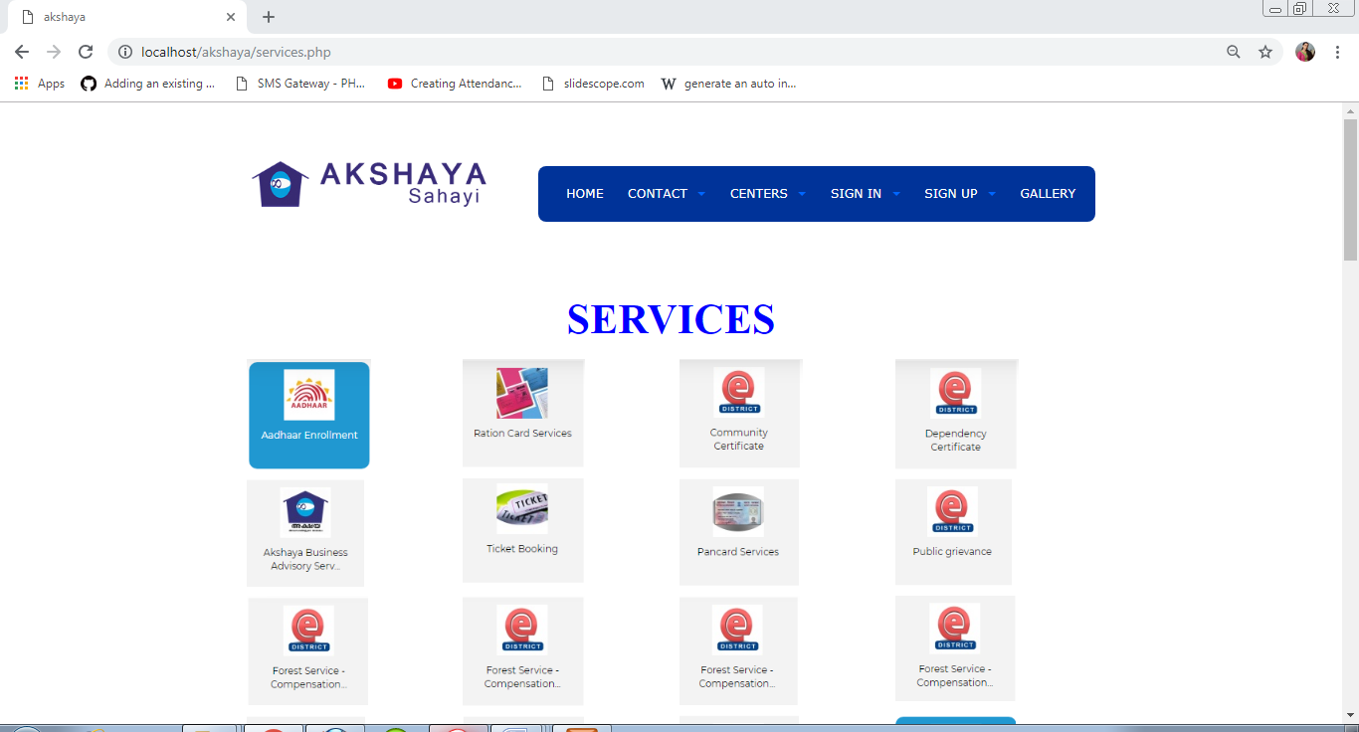

Admin Home page

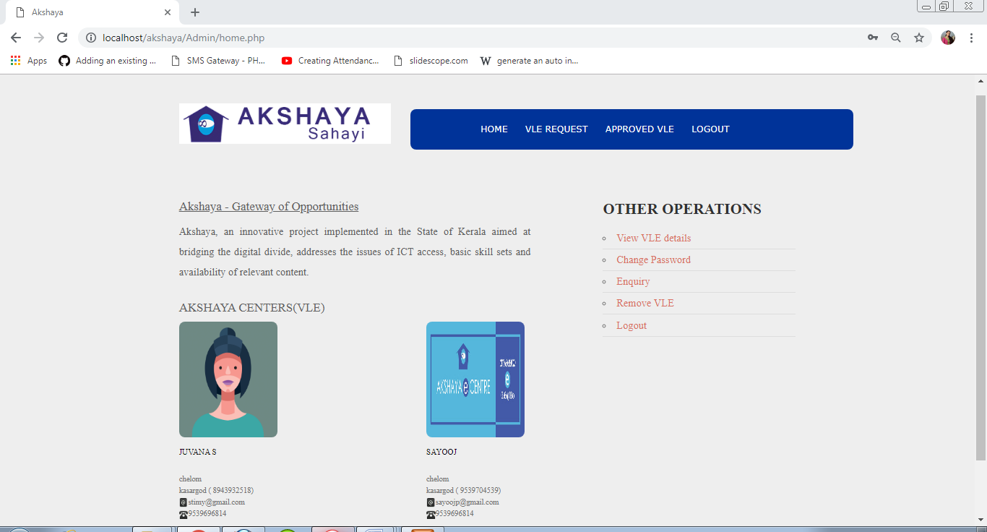

VLE Request

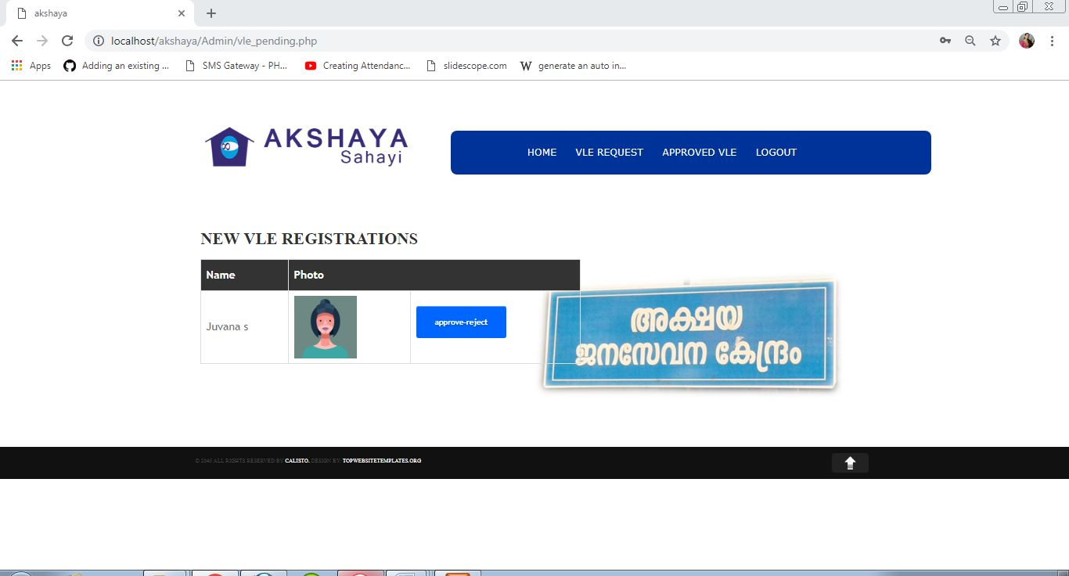

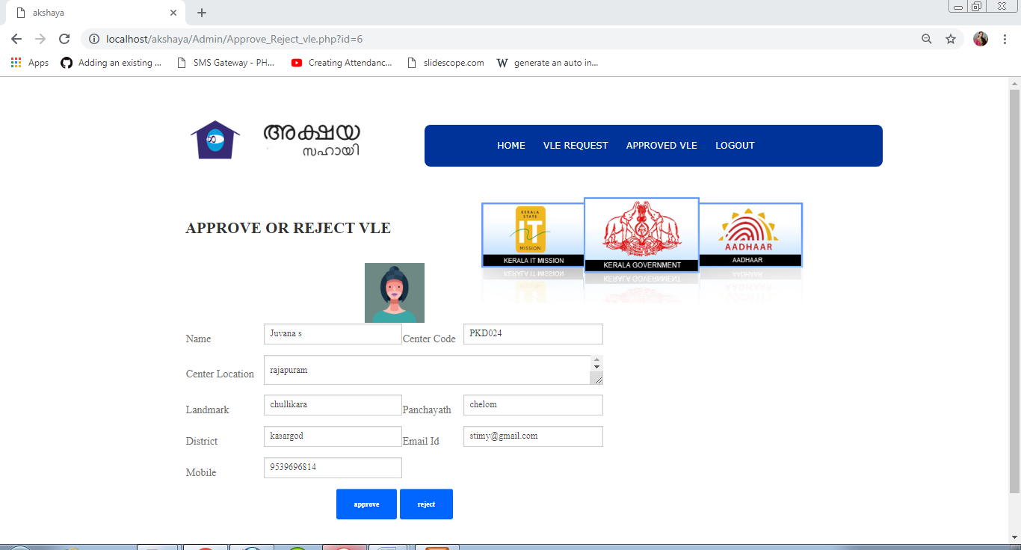

Approved VLE

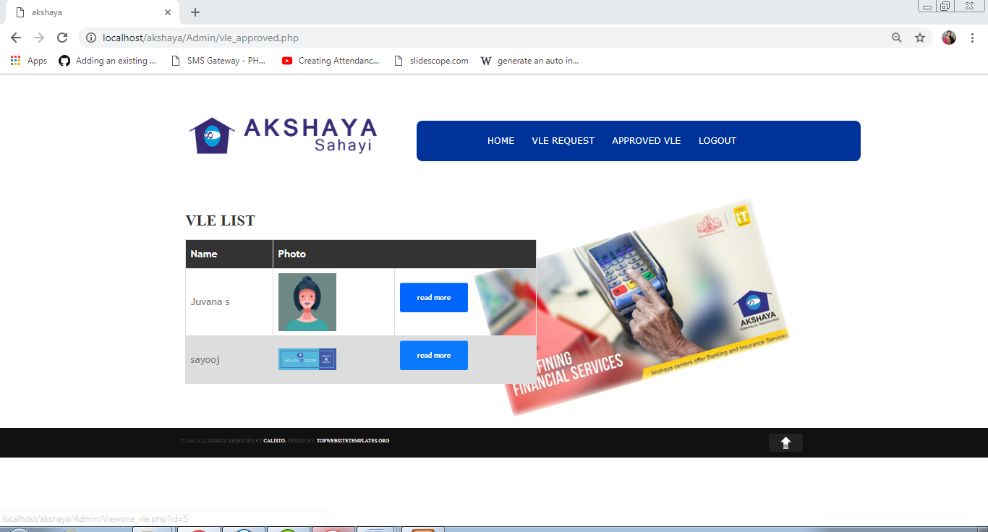

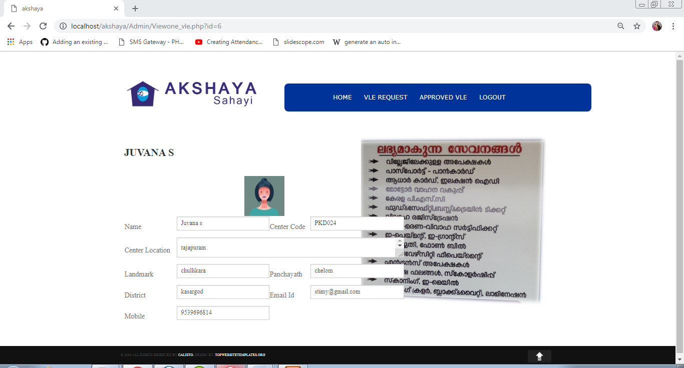

VLE home page

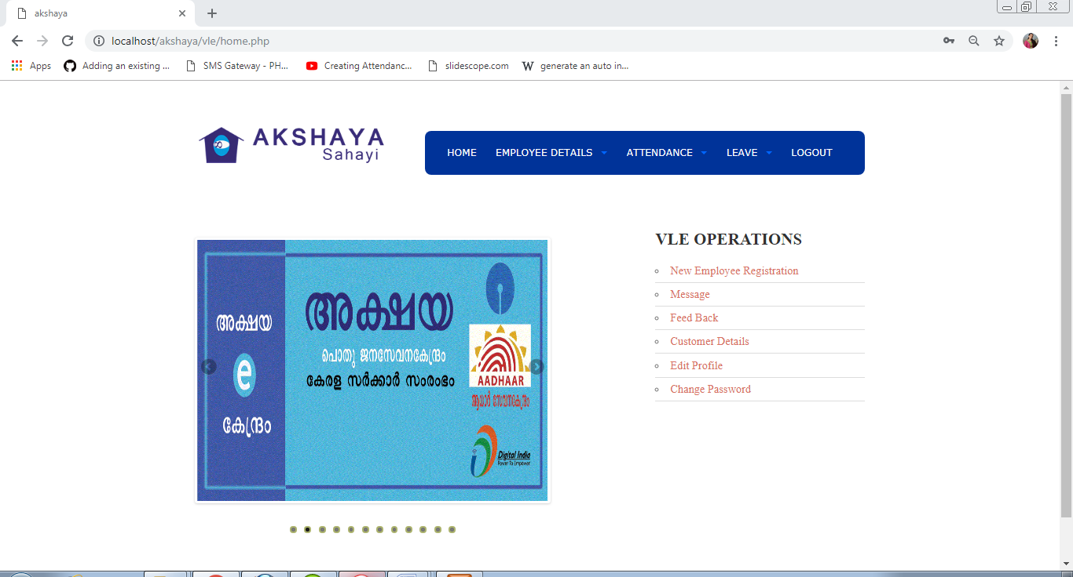

Employee Registration

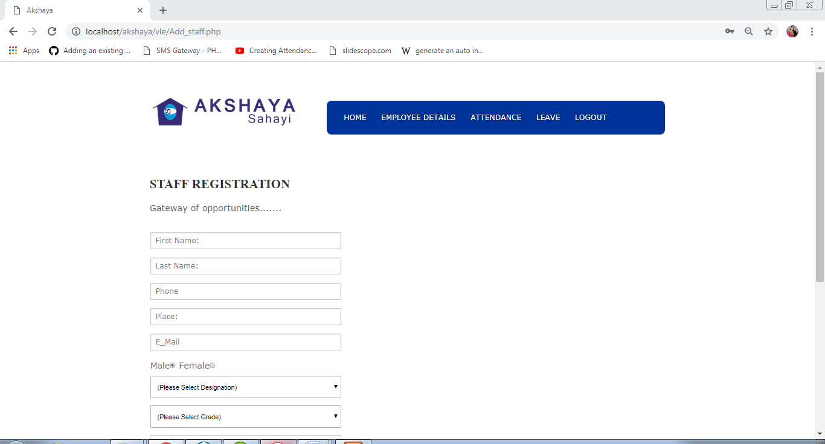

View employee details

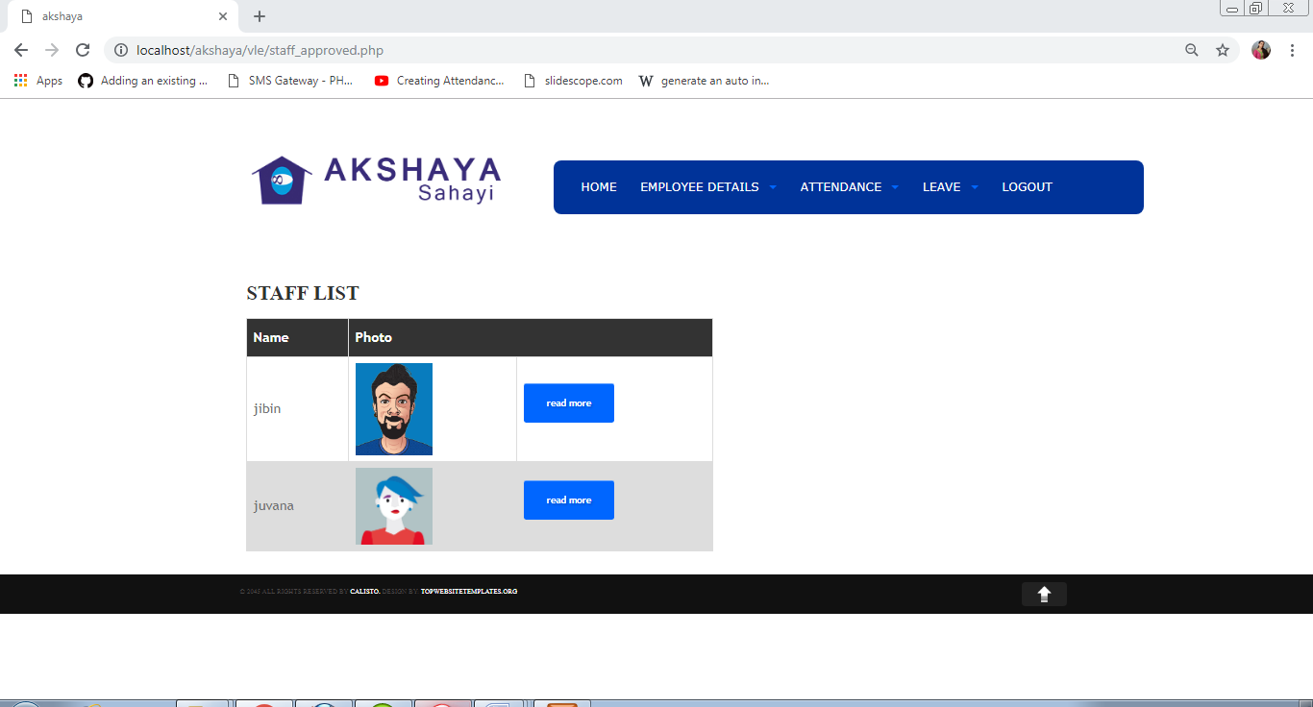

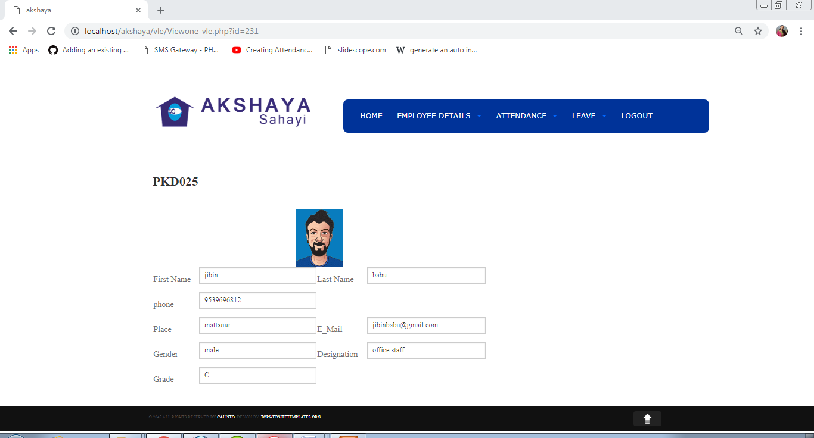

Update Details

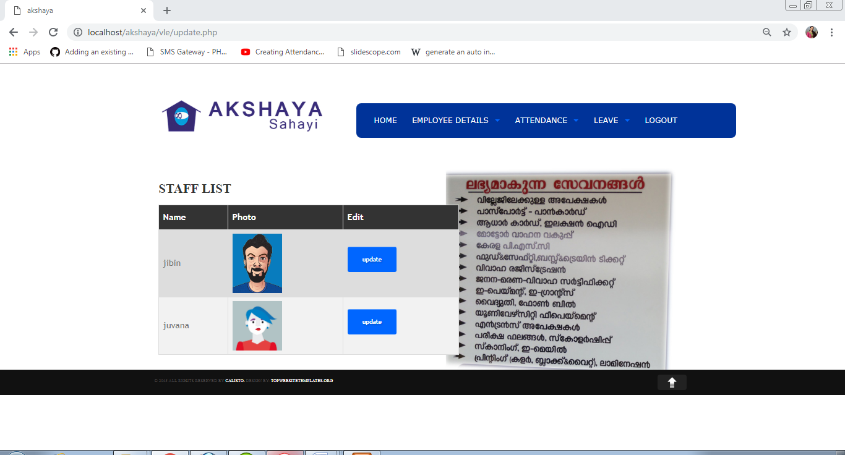

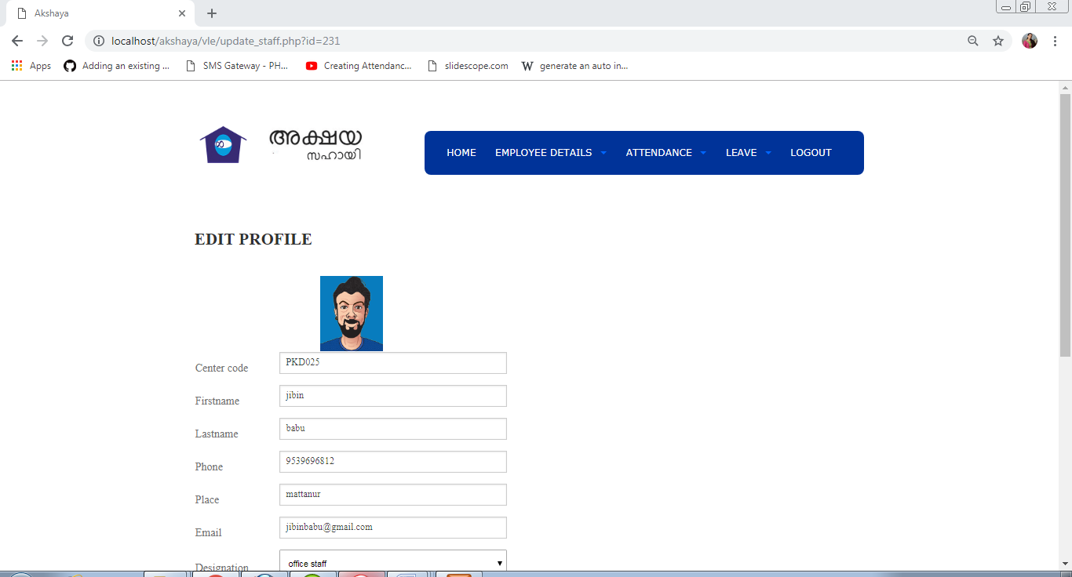

Delete Employee

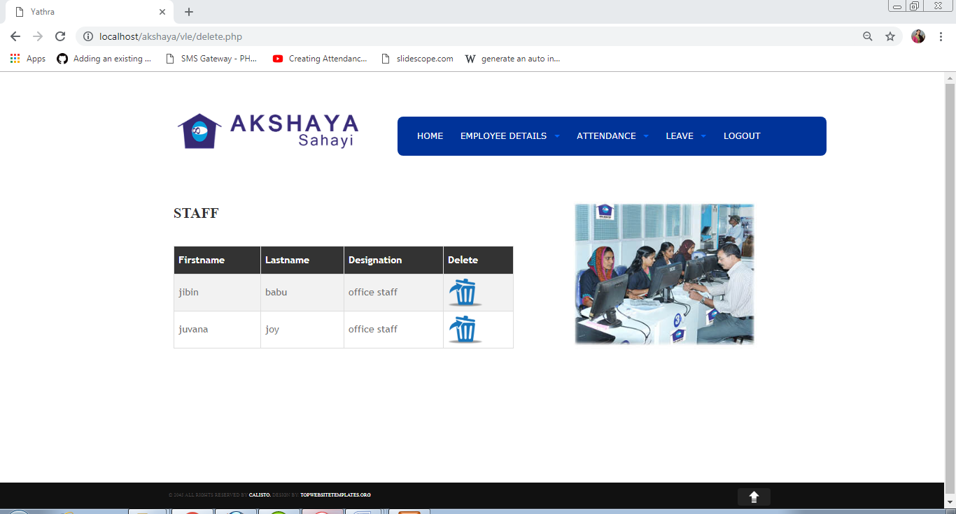

Attendance record

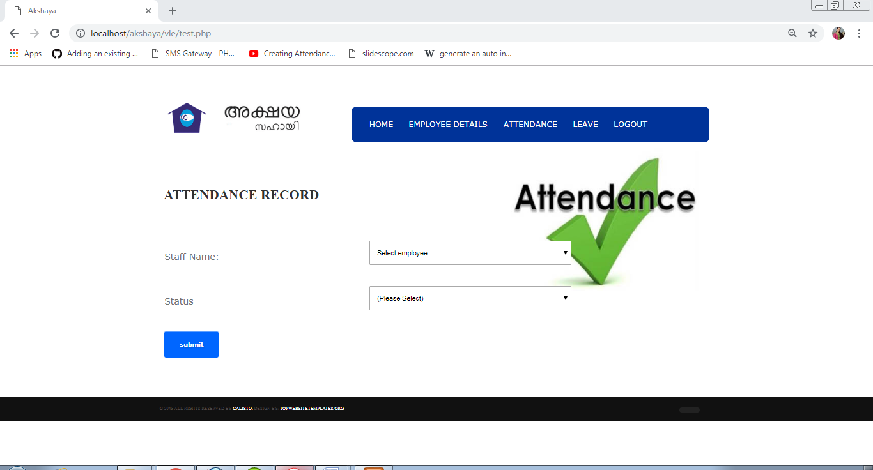

Attendance view

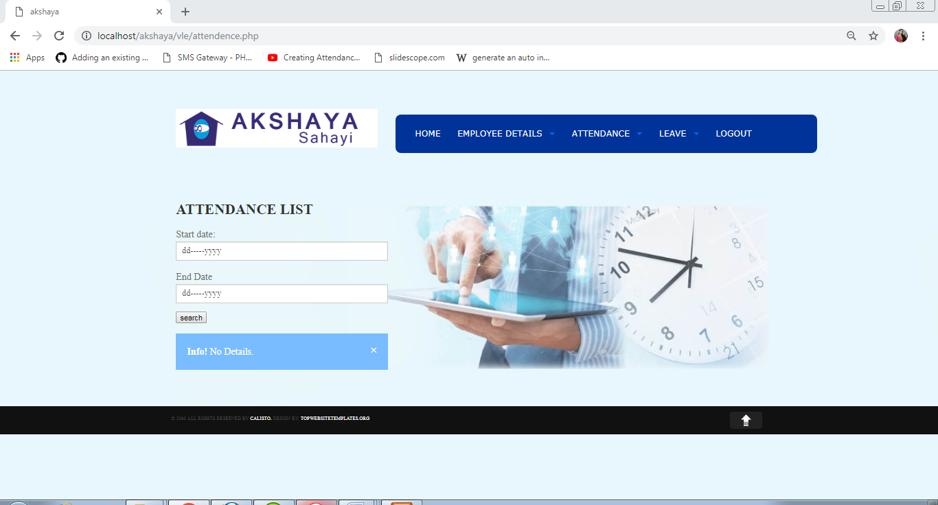

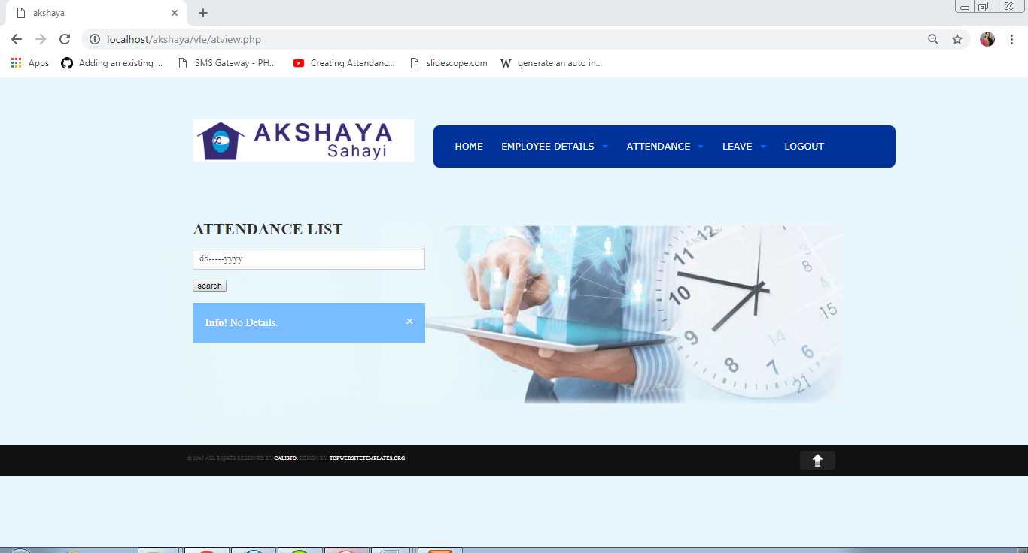

Approve/Reject Leave

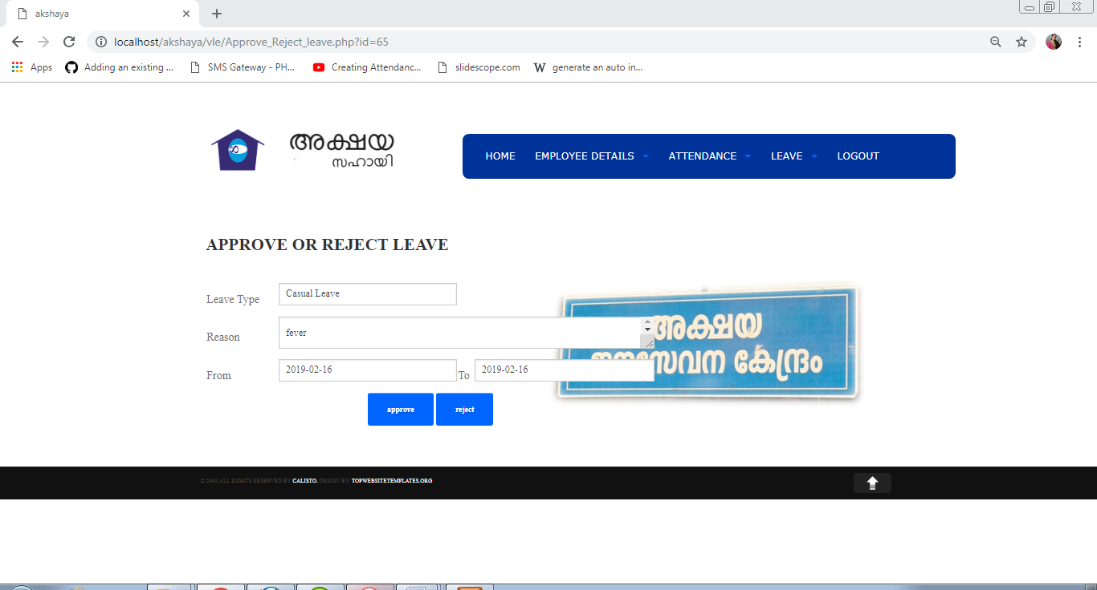

Message

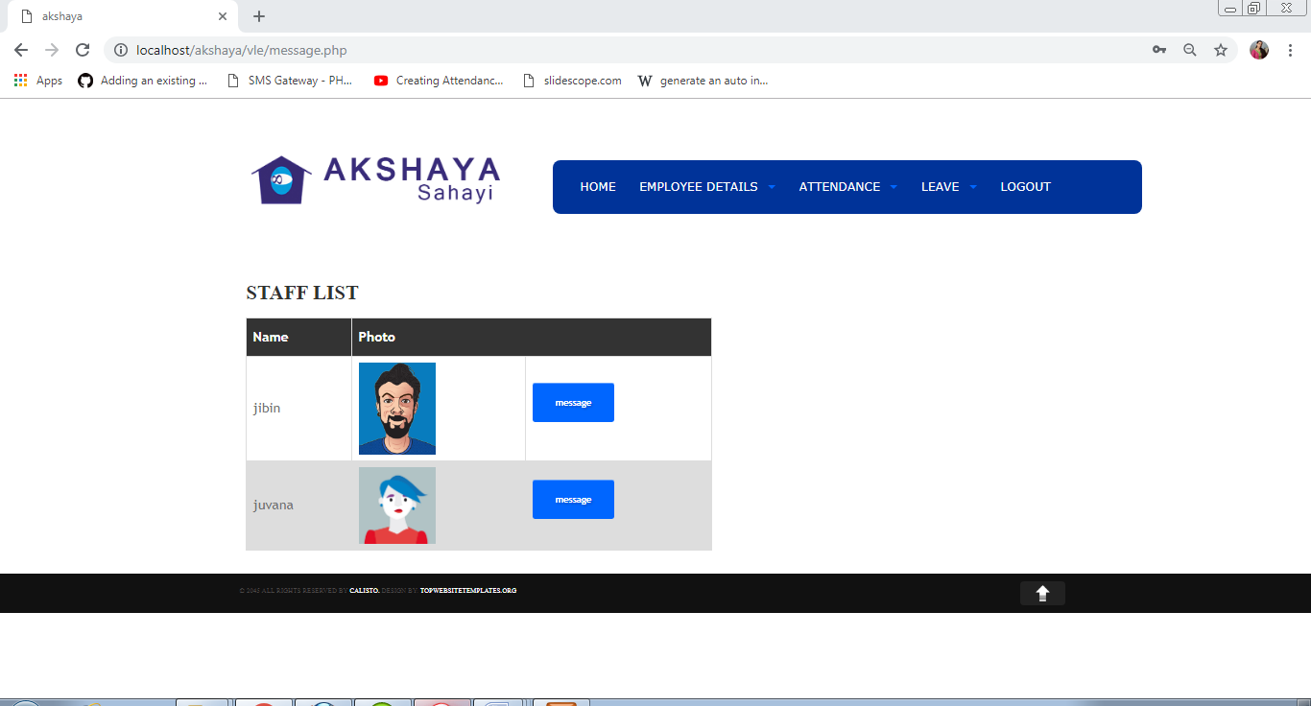

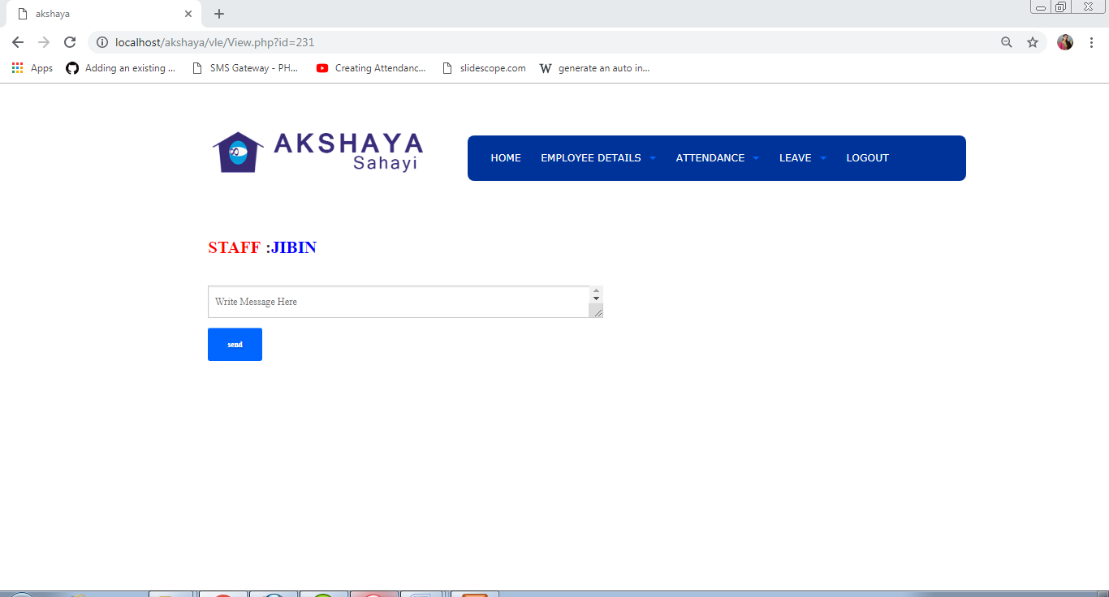

Feedback

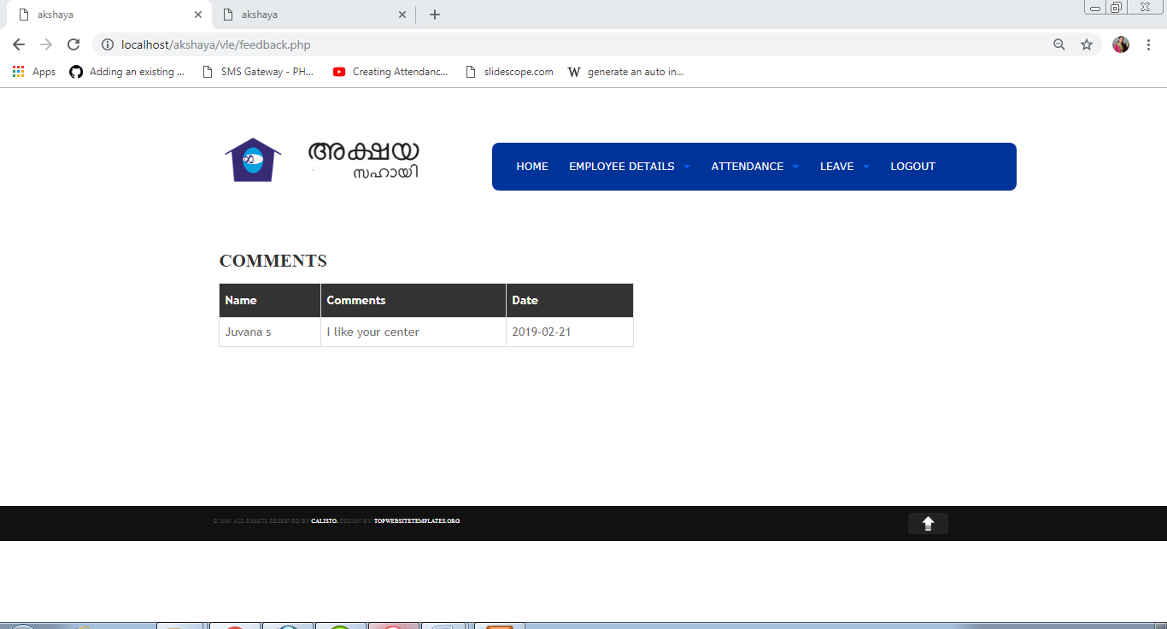

Customer Details

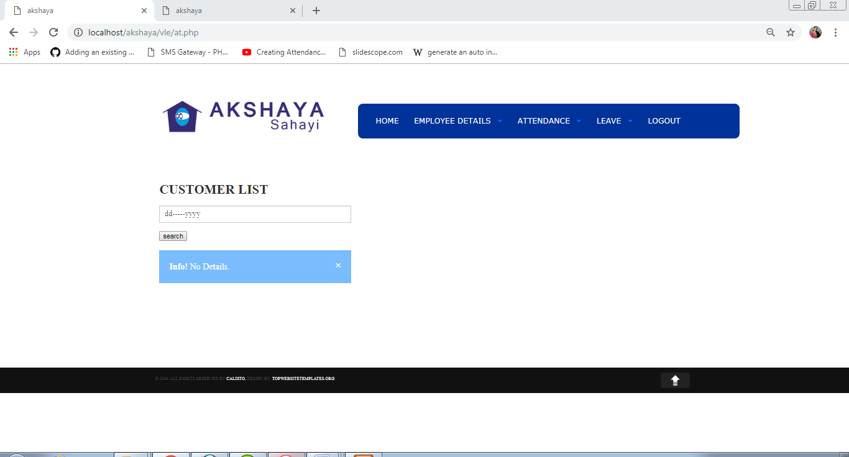

Edit profile

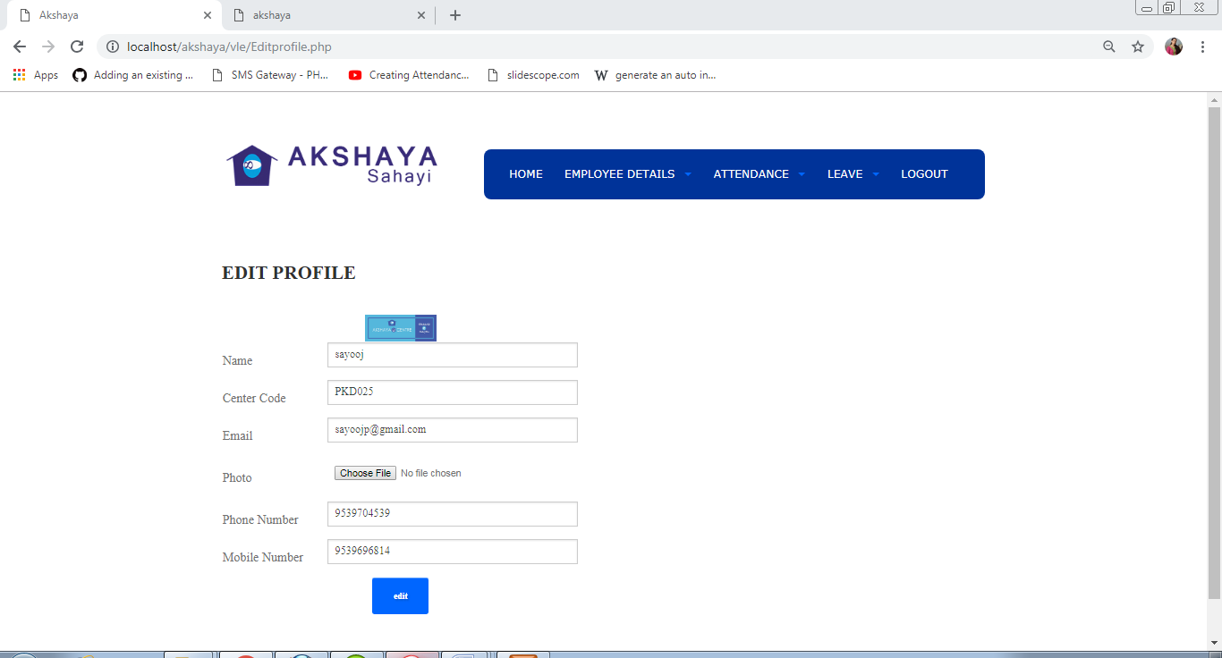

Change password

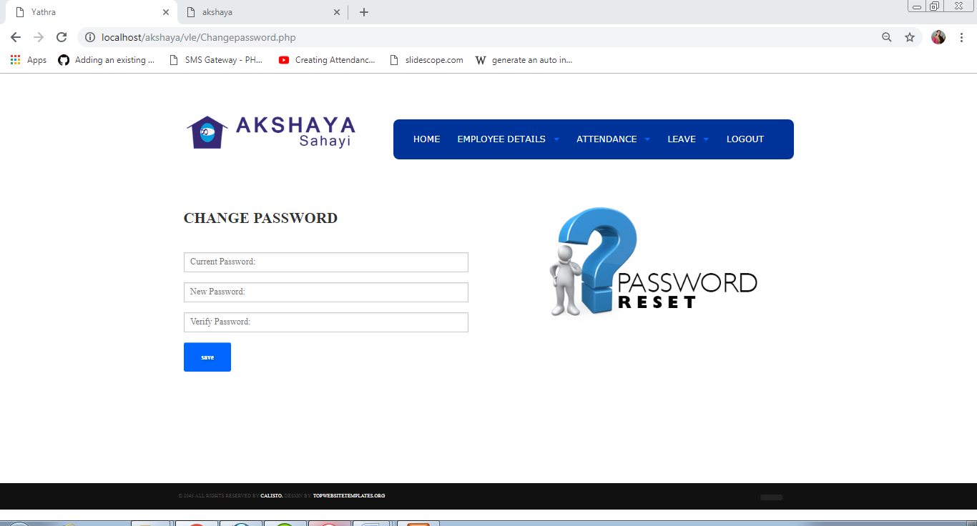

Staff home page

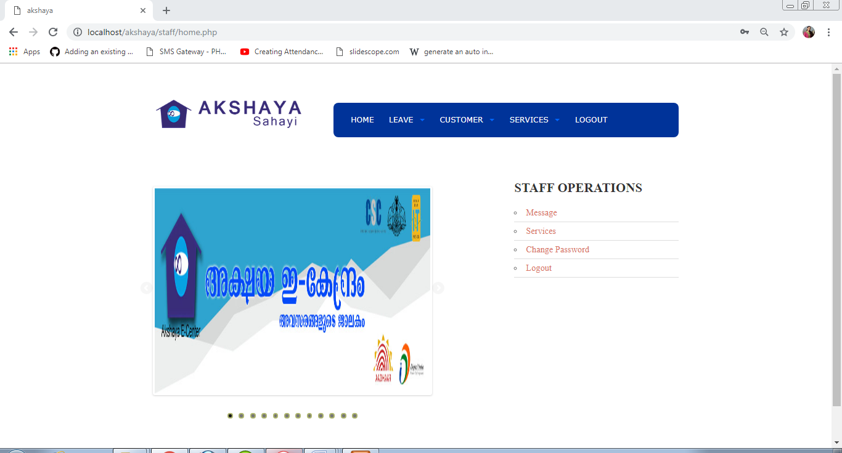

Leave Form

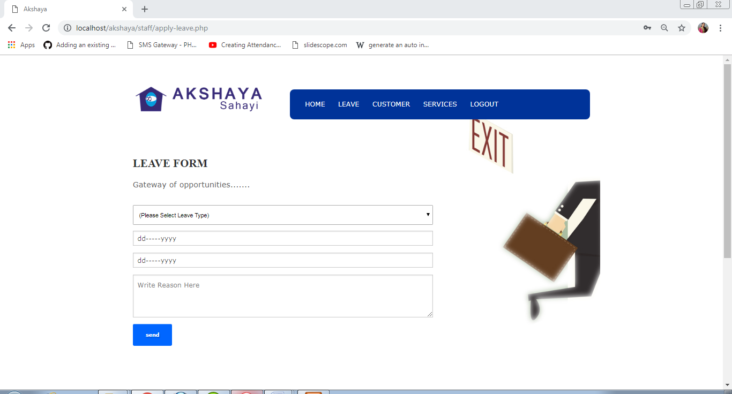

Leave Status

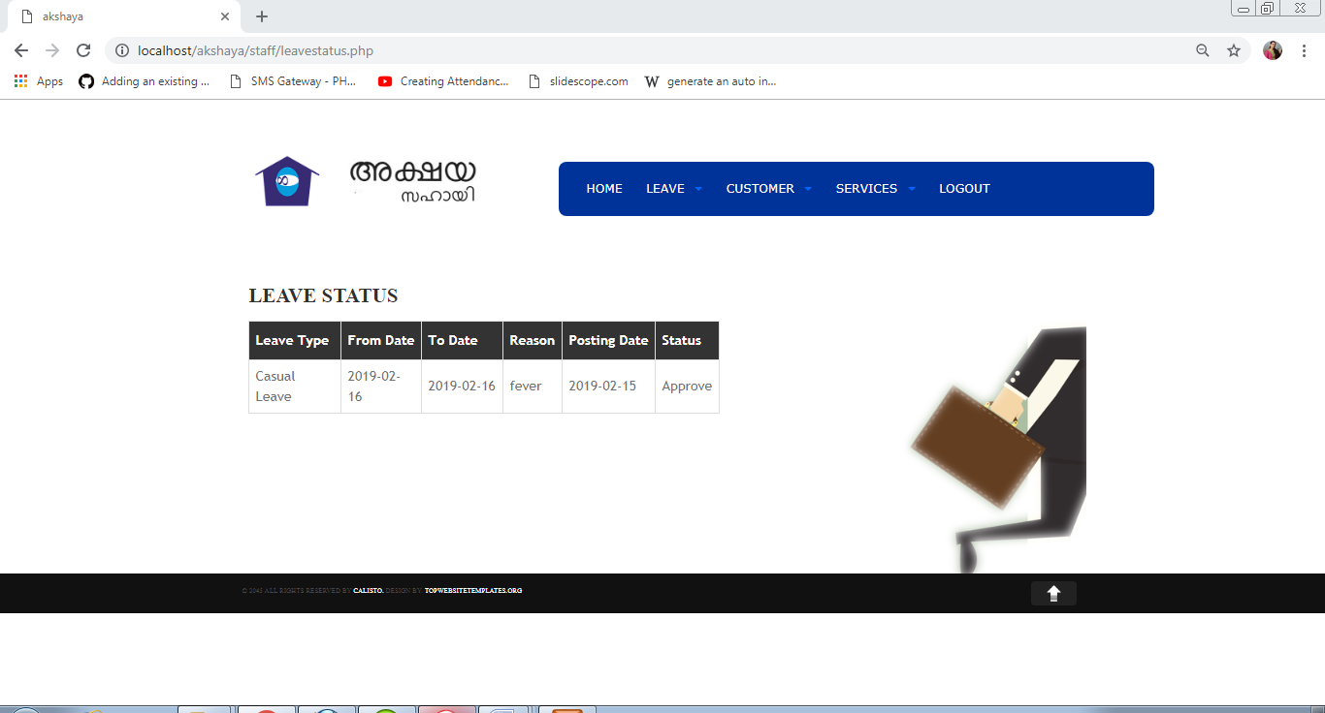

Customer Registration

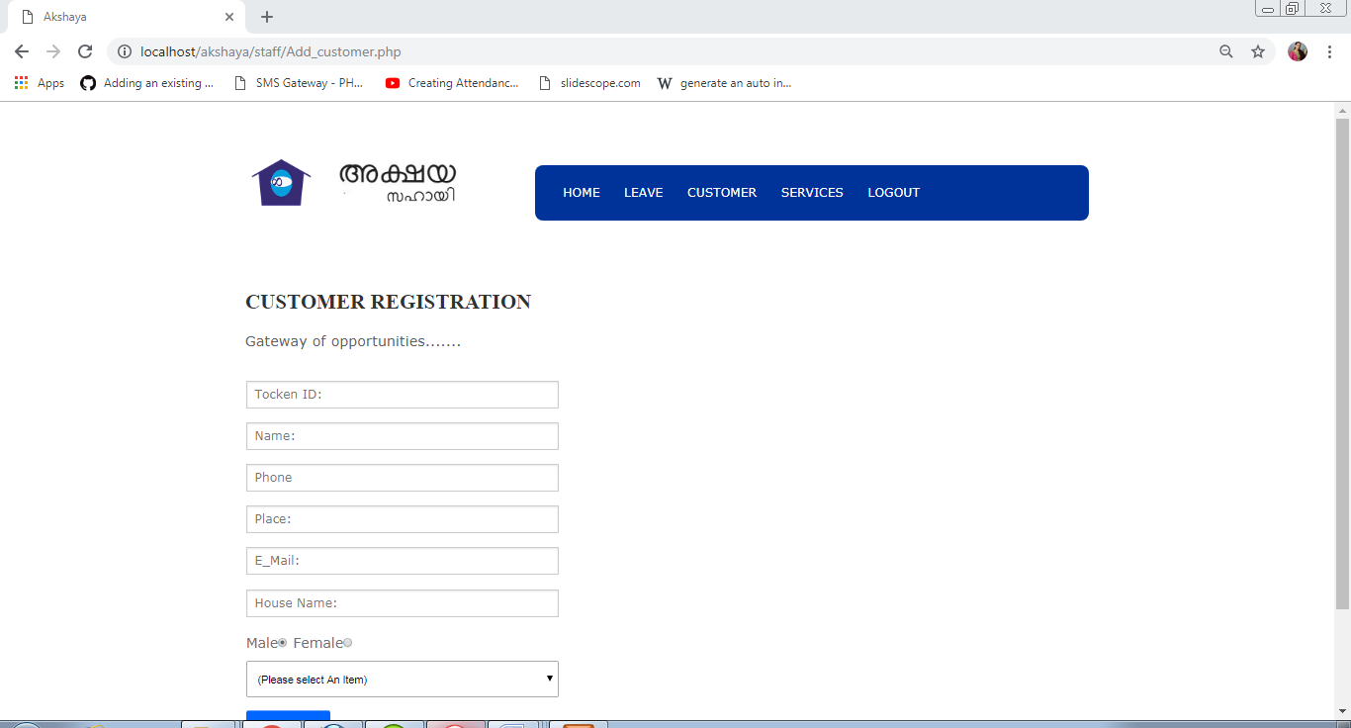

Payment

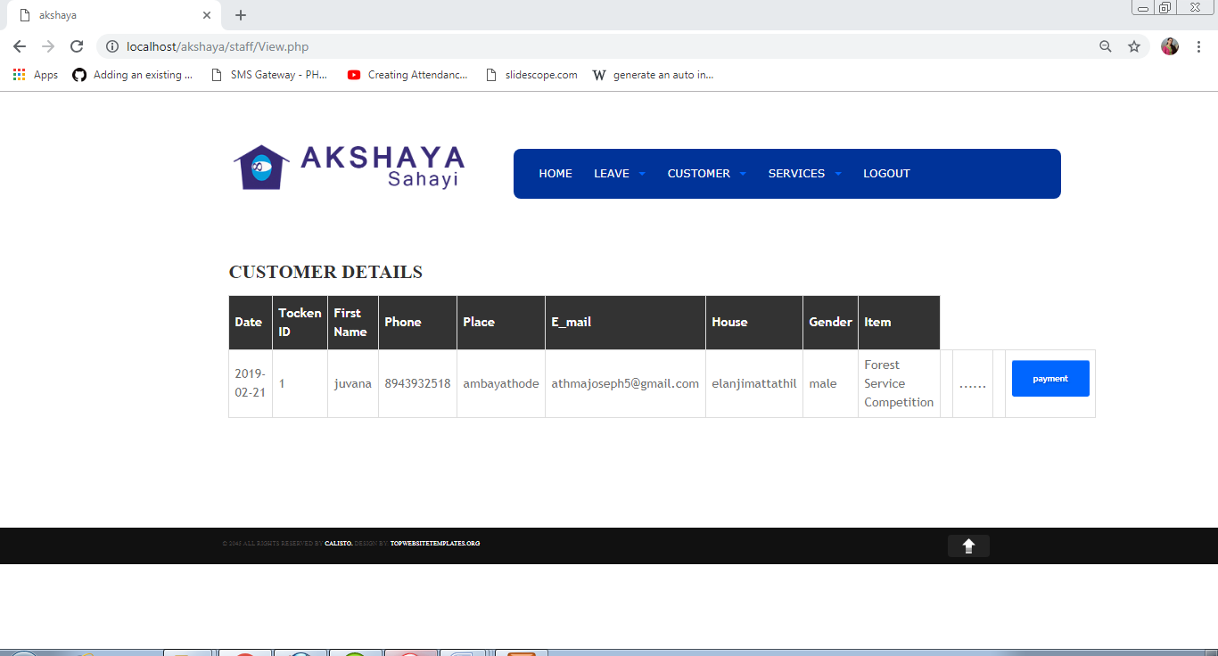

Bill Print

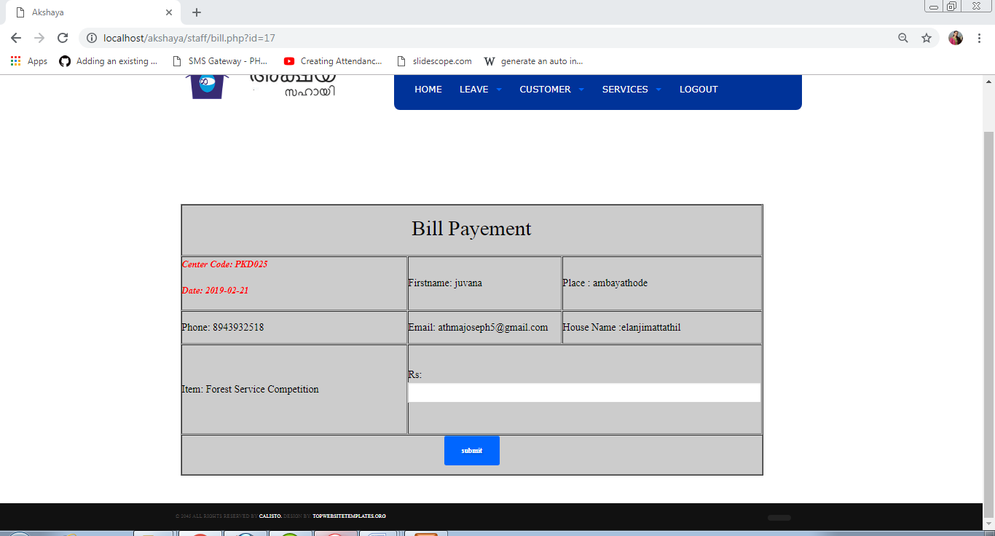

Customer Details

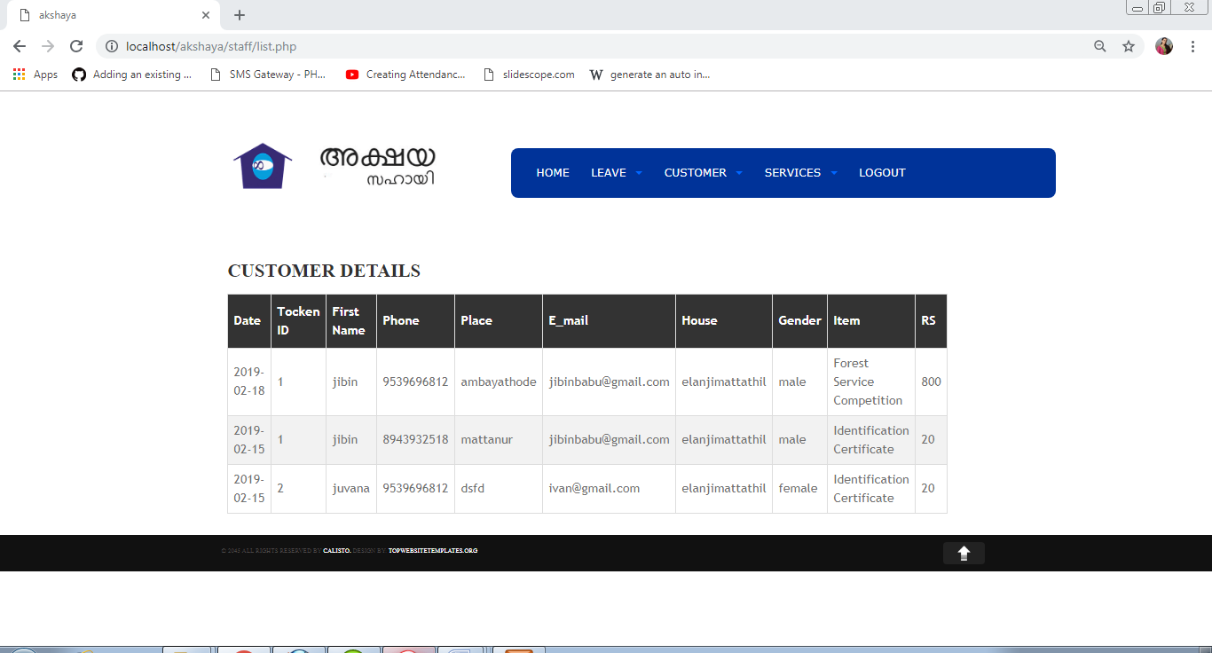

Change Password

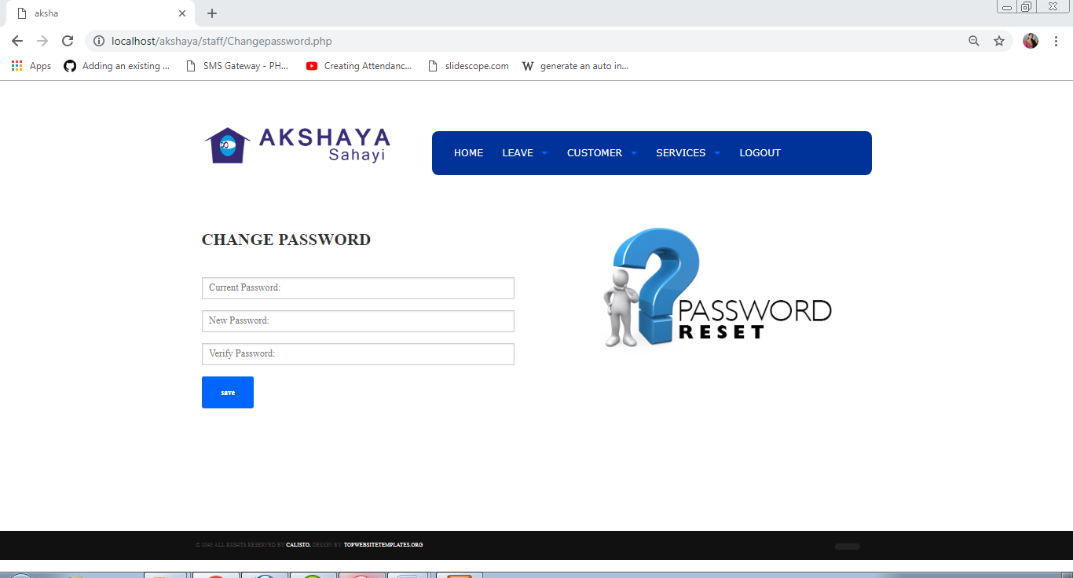

View Services

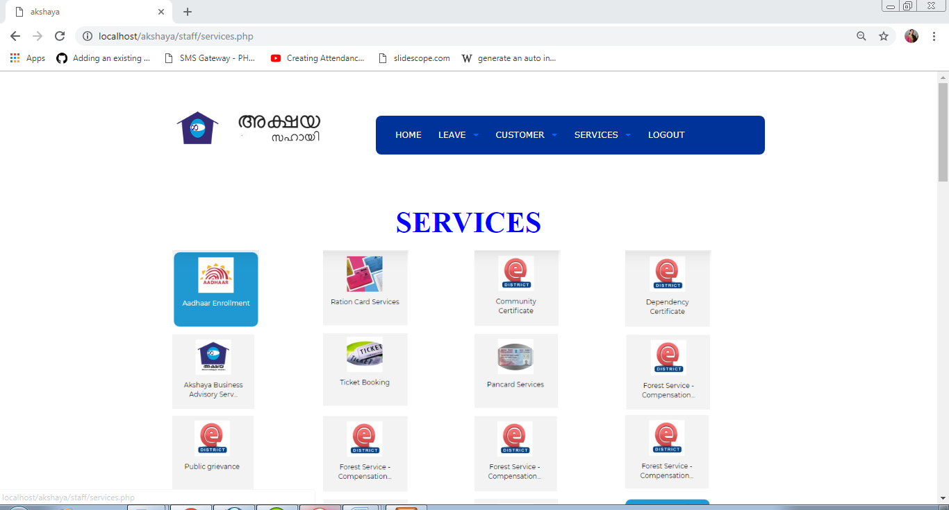

Message

